ACKNOWLEDGEMENT

I am grateful to each and everyone who has contributed in numerous ways to the development of this project whose efforts had been a helping hand in every footstep towards my destiny.
I give all the glory and honor to the God Almighty, whose divine touch had been the foremost inspiration and guiding light in the fulfillment of this uphill task.
I am glad to present the project report entitled “EYELESS DATA EXCHANGE WITH FACE DETECTION” prepared as a part of our sixth semester Master of Computer Application course.
I take this opportunity to express my deep sense of gratitude and sincere thanks to our Principal Dr. Saji C B, of Vidya Academy of Science and Technology, Thrissur for giving us an opportunity to take up the project work.
I would like to express my gratitude to Dr. V.N.Krishnachandran, Head of the Department of Computer Application, who has served as a host of valuable corrections. It is wordless to say thanks to our internal guide Mr Sajay K R extend my sincere gratitude to all other lecturers in the Computer Application department, who have contributed to complete my project.
I extremely thank my parents for their moral support and constant encouragement, which had always been a source of inspiration to me.

DRISYA P R

SYNOPSIS

“Eyeless data exchange with face detection” is an Python based project. Its main concern is to help the visually challenged to access their mails and reply to them. This project `enables smooth and reliable management of mails for a visually challenged person.
“Eyeless data exchange with face detection” can reduce the difficulties that a blind person has in accessing his/her mails. The security of the system is maintained by making use of the face detection mechanism of the blind to login. The main significance of our project is to avoid the problems faced by a visually challenged person in accessing his/her mails.
The project is concerned with converting the texts to speech (audible form) with the help of speech synthesizer. This enables the blind person to access mails and hear the contents of the mail. The project is also concerned with converting the speech to text with the help of the speech recognizer. This enables the blind to reply to his/her mails by speaking into a microphone.

CONTENTS

1. INTRODUCTION……………………………………….........……....5
1.1 Project Overview ……………………………………………..........5
1.2 Organization Profile ………………………………………….........5
2. SYSTEM ANALYSIS……………………………………….............7
2.1 The Existing System ……………………………………………...7
2.2 Proposed System……………………………………………… ....8
3. FEASIBILITY STUDY……………………………………………....9
3.1 Technical Feasibility…………………………………………….....9
3.2 Operational Feasibility…………………………………………....10
3.3 Economical Feasibility……………………………………………10
4. SOFTWARE REQUIREMENT SPECIFICATION…….…….......11
4.1 Functional Requirements…………………………………………12
4.2 Non Functional Requirements……………………………………12
4.3 System Configuration……………………………………………...13
4.3.1 Hardware Configuration…………………………………...........14
4.3.2 Software Configuration…………………………………............14
4.4 Conceptual Models…………………………………………...…...14
4.4.1 ER Diagram / Class Diagram…………………………….........15
4.4.2 Use Case / UML Diagrams……………………………….........18
5. SYSTEM DESIGN AND DEVELOPMENT…………………........20
5.1 Input Design………………………………………………………...20
5.2 Output Design …………………………………………..……….....21
5.3 Database Design…………………………………………………...22
5.4 Process Design ………………………………………………...…..24
6. SYSTEM IMPLEMENTATION AND TESTING…………..............26
6.1 System Implementation…………………………………………….26
6.2 System Testing………………………………………………….......91
7. SYSTEM SECURITY MEASURES………………………………...96
8. CONCLUSION ……………………………………………………….98
9. SCOPE FOR FUTURE ENHANCEMENT…………………….......99
10. BIBLIOGRAPHY…………………………………………………...100
11. APPENDIX…………………………………………………………..101
11.1 Data Flow Diagrams……………………………………………....101
11.2 Table Structure………………………………………………….....106
11.3 Sample Screen Formats………………………………………….108
11.4 Reports.........................................................................................111

- INTRODUCTION

  - Project Overview

The goal of this project is to help the visually challenged person to access their mails.Nowadays an email account is necessary. Persons with inabilities are also living in this world so, an email account is also necessary for them. The purpose of” Eyeless data exchange with face detection” is to help the person with such inabilities.

The project is concerned with converting the texts to speech (audible form) with the help of speech synthesizer. This enables the blind person to access mails and hear the contents of the mail. The project is also concerned with converting the speech to text with the help of the speech recognizer. This enables the blind to reply to his/her mails by speaking into a microphone.

  - Organization Profile

Syntax Soft is an aggressive catalysts helping customers to leverage technology to accelerate adaptation.Our focus is singular and clear: offer business benefits to the customer to deliver an unbeatable edge over competition. That's the bottom line we like to put on top of everything else. All our passion, all our values, our strengths, skills and efforts orbit around this positioning. The idea of offering endless value to the customer is the very differentiating principle Syntax was founded on.Building up from the direction our foundation gave us, our guaranteed, unwavering quality of delivery was built up by sheer determination, expertise and commitment.
Having started in 1998 with a one-man team and a single client, Syntax today has a manpower base of over 150 that is expected to double within the year and a list of clients that reads like a Who's Who list of companies spread across geographies. Syntax has now attained the position of an emergent powerhouse in Technology consulting, product development and Outsourcing services.This amazing growth has resulted from the tremendous confidence Syntax has evoked in everyone alike - Management, Employees, Investors, Partners, Alliances and, of-course, our Clients. On the ground, Syntax is a people company. The company's backbone is its strong management team that keeps focused on the magic of the initial vision. In addition, the expertise and energy of the founders has filtered down to the entire team making it one complete dynamic entity with strong commitment and focus.Syntax fundamentally aims to build strong relationships. Our deliverables are strong technology solutions that make a difference to the profitability of our clients' businesses.Our fundamental values can be defined by our Vision, Mission and Philosophy.
Vision
To be one of the top IT Consulting Companies in India and abroad.
Mission
To leverage Technology & Human Capital for Optimum Productivity.
Philosophy
To create an opportunity & to provide a platform where everybody can grow & contribute towards making India a 'Super Power' & the World a better place to live in.
Syntax Soft-Tech India Pvt. Ltd
Marine Drive ,cochin-31

- SYSTEM ANALYSIS

The first stage of any project, sometimes called the initial study is the brief investigation of system under consideration. Initial study is the problem solving activity that requires intensive communication between the system users and the system developers. It does various feasibility studies .in these studies, a rough figure of the system activities can be obtained from which the decisions about strategies to be followed for the effective system study and analysis can be taken. To launch a system investigation, we need a master plan detailing the steps to be taken, the people to be questioned in the outcome expected. Initial study also identifies the methods of the data collection to be followed. The most critical phase of managing system projects is planning.
The initial investigation has the objective of determining whether the user request has potential merit. The major steps in defining the user requirements are:

- Studying the present system.
- Verify the problem
- Defining the performance expected by the candidate system

2.1 The Existing System

The current mailing system is difficult in various circumstances for the blind to gain access to his mails. In the existing system, the user logins by entering his mail id and password. The blind cannot enter his mail id and password by his own. So he needs to depend on others which makes it unsecure. In the current system the mails are read and replied to in the form of text.
LIMITATION OF EXISTING SYSTEM
- Difficult to login
- Unsecure
- Needs a greater level of dependency on others
- Unreliable
- Difficult to read and write

2.2 PROPOSED SYSTEM
The proposed system is to computerize all the manual activities in the existing system. Proposed system provides the facilities for reading and writing mails. The security is maintained by making use of the user’s finger print. In the current system the mails are read and replied to in the form of text. This is not applicable for a visually challenged. So here we propose a system in which the inbox mails in the form of text are converted into speech (audible form) which can be heard by the user through a headset. In order to write mail, he can just speak into microphone and his voice will be converted into text. The text is then sent to the recipient.
Advantages of Proposed System
- Provides a very important application to a disabled person.
- Provides security
- Reduce human effort
- Reduce the dependency on others

3. FEASIBILITY STUDY

The objective of feasibility study is to determine whether the proposed system is feasible. In this stage, the aim is to provide solutions of the stated problems usually in the form of specification to meet the user requirements and to make recommendations for a new computer based system. Feasibility study is a major step in the software life cycle. It focuses on:
- Finding out whether a new system is required or not.
- Determine the potentials and drawbacks of the existing system
- Identification of user requirements and the benefits expected by the user from the resulting system.
- Finding out the various alternatives available.
- Knowing what should be incorporated in the new system.
- Define the ingredients and objectives involved in the project.
Feasibility study is conducted to test whether the system is beneficial to the organization. The feasibility study analyses potential solutions against a set of requirements, evaluate their ability to meet these objectives, describe a recommended solution, and offer a justification for the selection.

3.1 Technical Feasibility
Feasibility study has been done to gather required information. Training, experience and commonsense are required for collection of the information. Data was gathered and checked for completeness and accuracy. This system requires a multiple user environment. It needs powerful RDBMS database SQL Server to the purpose. So, this system is technically feasible.
Analyzing the data involved identification of the components of the system and their inter relationship and identifying the strength and weakness of the system.
The main points that are considered to prove that the project is technically feasible are:
- The present technology is sufficient to develop the project.
- The proposed system provides adequate response to the user.
- The system can be expanded and developed.

3.2 Operational Feasibility
There is no difficulty in implementing the system. The proposed system is effective, user friendly and functionally reliable that the user in the company will find the new system reducing their hardship. The user of the system must be completely unaware of the internal working of the system so that the users will not face any problem running the system. The system thus reduces the responsive time of computer thereby, the system is found to be operationally feasible.
Design is the only way that can accurately translate customer registration into finished software or system. Without software design, the risk of building an unstable system exists. System design provides the procedural details necessary for implementing the system recommended in the feasibility study.
3.3 Economical Feasibility
Economic and Financial analysis is used for evaluating the effectiveness of the candidate system. My project is technically and operationally feasible. But when posting the system in the internet it may cost a little, but it could be made from the registering companies. So we can say the system is financially feasible as well.
The developing system must be justified by cost and benefit. Economic feasibility is concerned with savings, increased profit and reduction. This is an ongoing effort that improves accuracy at each phase of the system life cycle. Economic feasibility is the most frequently used method for evaluating the effectiveness of the candidate system, more commonly known as cost/benefit analysis. The procedure determines the benefits that are expected from the candidate system and compare them with cost involved. If the benefit outweigh the cost then the system is economically feasible.

4. SOFTWARE REQUIREMENT SPECIFICATION

The system environments with regard to an application project are the environments which shaped the flesh and bones of the system from the concepts and ideas to a real working model. It is so crucial in selecting the various environments for the system development since they plays a vital role in determining the properties and behaviour of the system. The overall project development is associated with the system environment selected. So the system environment should be selected such that the project development becomes smooth and easy. So a detailed study should be conducted and proper system environment should be selected. Basically the system environment is divided into Software Configuration and Hardware Configuration.
There is no a clear distinction between functional and non-functional requirements. Whether or not a requirement is expressed as a functional or a non-functional requirement may depend:

- On the level of detail to be included in the requirements document
- The comprehension of application domain and the desired system experience of developers.

Some properties of a system may be expressed either as a functional or non-functional property. Example The system shall ensure that data is protected from unauthorized access. Conventionally a non-functional requirement (security) because it does not specify specific system functionality expressed as functional requirement: The system shall include a user authorization procedure where users must identify themselves using a login name and password. Only users who are authorized in this way may access the system data. Non-functional requirements may result in new functional requirements statements.
4.1 Functional Requirements

Valid Registration
To access the functionalities of tis system users want to register into the system.They can login into the system with valid information. Only approved users can login into the system.

Message Management
The messages should be stored actually in the mail server. Messages should be received only to registerd users
Text to Speech Conversion
It is the process of converting a text file into a spoken language. The speech synthesizer with the help of a speech engine.
Speech to Text Conversion
It is the process of converting spoken language to written text or some similar form.

4.2 Non-Functional Requirements
Performance
It provides better performance than existing system. Because Its main concern is to help the visually challenged to access their mails and reply to them. This project enables smooth and reliable management of mails for a visually challenged person.Here the message converting the texts to speech (audible form) with the help of speech synthesizer. This enables the blind person to access mails and hear the contents of the mail. The project is also concerned with converting the speech to text with the help of the speech recognizer. This enables the blind to reply to his/her mails by speaking into a microphone.

Availability
Availability is the proportion of time a system is in a functioning condition.Here the system is always available.

Portablty
Portability in high-level computer programming is the usability of the same software in different environments. Since it is a web application it can be implemented in different environments.
Security
The security is maintained by making use of the user’s finger print.The admin is the one who grand the permission to access the system.
Maintainablity
The system shall provide the capability to backup the database. In this system the language English, can only be recognised. In future, we can extent the system by including more languages and can recognise more languages.
Reliablity
The system shall be available 99.9% of time

4.3 System Configuration

A system configuration (SC) in systems engineering defines the computers, processes, and devices that compose the system and its boundary. More general the system configuration is the specific definition of the elements that define and/or prescribe what a system is composed of. Alternatively the term system configuration can be used to relate to a model. A properly-configured system will allow you to avoid nasty resource conflict problems, and make it easier for you to upgrade your system with new equipment in the future. An improperly-configured system will lead to strange errors and problems, and make upgrading a big problem.

4.3.1 Hardware Configuration
Processor: Intel CORE i3
Clock speed: 3.0 GHz
Ram size: 4 GB
Hard disk capacity: 160 GB
Monitor type: 15 Inch monitor
Keyboard type: Standard Keyboard
4.3.2 Software Configuration
Operating System: Windows 7 OR HIGHER VERSION
Front End:Python,Windows Application in .NET
Back End:MySQL
IDE:Visual studio code
Web Server:APACHE
Browser : Any Browser

4.4 Conceptual Models

A conceptual model is a model made of the composition of concepts, which are used to help people know, understand, or simulate a subject the model represents. It is also known as a domain model. Conceptual modelling should not be confused with other modelling disciplines such as data modelling, logical modelling and physical modelling. The conceptual model is explicitly chosen to be independent of design or implementation concerns. The aim of a conceptual model is to express the meaning of terms and concepts used by domain experts to discuss the problem, and to find the correct relationships between different concepts. The conceptual model attempts to clarify the meaning of various, usually ambiguous terms, and ensure that problems with different interpretations of the terms and concepts cannot occur. Such differing interpretations could easily cause confusion amongst stakeholders, especially those responsible for designing and implementing a solution, where the conceptual model provides a key artefact of business understanding and clarity.

4.4.1 ER Diagram

Entity Relationship (ER) Diagram uses the conceptual modeling using symbols. An ER analysis uses three major abstractions to describe data. They are:

Entity
Relationship
Attribute

Entities are distinct things in the enterprise, relationships and meaningful interaction. Between the object and attributes are the properties of the entity and the relationships.
Each individual object is called an entity, a collection of similar objects or entities are called an entity set. Relationship set is a collection of relations. The interactions in entity set are modeled by relationship set.

Symbol | Meaning
 | Entity
 | Relationship
 | Attribute
 | Weak Entity
 | Weak Entity Relationship
 | Multivalued Attribute
 | Key Attribute
 | Composite Attribute

4.4.2 Use Case

Purpose

The use case diagram is used to model the dynamic aspect of the system .A use case diagram shows a set of use cases and actors and their relationships. The use case diagram is mainly used to give an overall view of events that takes place in a trip planning. It specifies flow of events in a trip planning. A use case diagram can be used to view the system‘s functionality from an outside-in perspective and to develop system tests.
Use case diagrams depict:

- Use cases: A use case describes a sequence of actions that provide something of measurable value to an actor and is drawn as a horizontal ellipse.
- Actors: An actor is a person, organization, or external system that plays a role in one or more interactions with your system. Actors are drawn as stick figures.
- Associations: Associations between actors and use cases are indicated in use case diagrams by solid lines. An association exists whenever an actor is involved with an interaction described by a use case. Associations are modeled as lines connecting use cases and actors to one another, with an optional arrowhead on one end of the line. The arrowhead is often used to indicating the direction of the initial invocation of the relationship or to indicate the primary actor within the use case. The arrowheads are typically confused with data flow and as a result I avoid their use.
- System boundary boxes (optional): You can draw a rectangle around the use cases, called the system boundary box, to indicate the scope of your system. Anything within the box represents functionality that is in scope and anything outside the box is not. System boundary boxes are rarely used, although on occasion I have used them to identify which use cases will be delivered in each major release of a system.
- Packages (optional): Packages are UML constructs that enable you to organize model elements (such as use cases) into groups. Packages are depicted as file folders and can be used on any of the UML diagrams, including both use case diagrams and class diagrams. I use packages only when my diagrams become unwieldy, which generally implies they cannot be printed on a single page, to organize a large diagram into smaller ones.

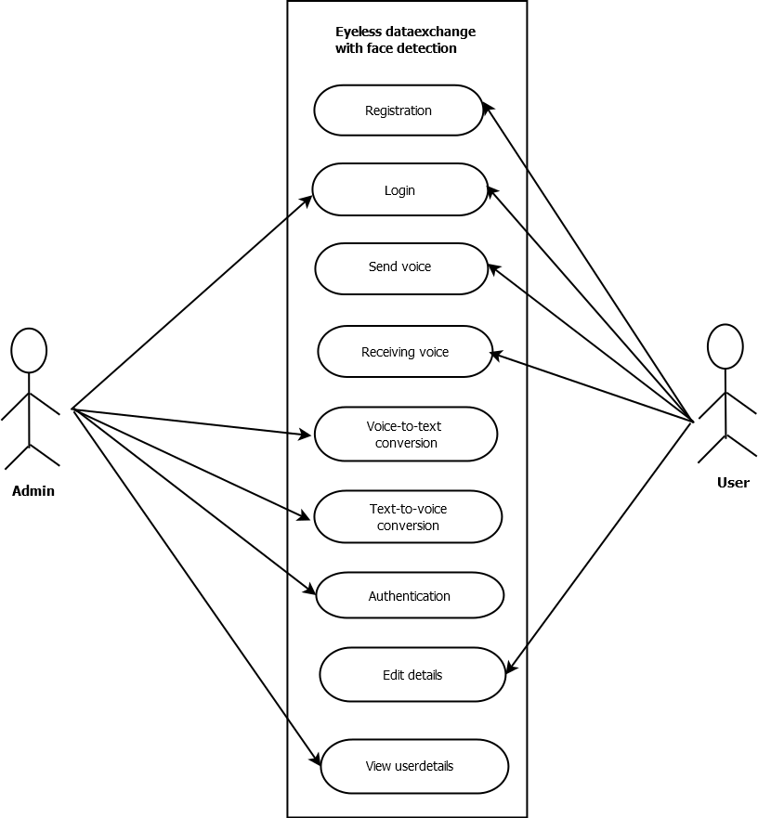

5. SYSTEM DESIGN AND DEVELOPMENT

System designing in terms of software engineering has its own value and importance in the system development process as a whole. To mention it may though seem as simple as anything or simply the design of systems, but in a broader sense it implies a systematic and rigorous approach to design such a system which fulfils all the practical aspects including flexibility, efficiency and security.
Systems design is the process of defining the architecture, components, modules, interfaces, and data for a system to satisfy specified requirements. Systems design could be seen as the application of systems theory to product development.
The system design covers the following

- Reviews the current physical system
- Prepares output specifications
- Prepares input specifications
- Prepares edit, security and control specifications
- Specifies the implementation plan
- Prepares a logical design walk through of the information flow, output, input, controls and implementation plan.
5.1 Input Design
The input design is the link between the information system and the user. It comprises the developing specification and procedures for data preparation and those steps are necessary to put transaction data in to a usable form for processing can be achieved by inspecting the computer to read data from a written or printed document or it can occur by having people keying the data directly into the system. The design of input focuses on controlling the amount of input required, controlling the errors, avoiding delay, avoiding extra steps and keeping the process simple. The input is designed in such a way so that it provides security and ease of use with retaining the privacy. Input Design considered the following things that are what data should be given as an input, how the data should be arranged or coded, dialog to guide the operating personnel in providing input and methods for preparing input validations and steps to follow when error occur.

Input objectives

- Input Design is the process of converting a user-oriented description of the input into a computer-based system. This design is important to avoid errors in the data input process and show the correct direction to the management for getting correct information from the computerized system.
- It is achieved by creating user-friendly screens for the data entry to handle large volume of data. The goal of designing input is to make data entry easier and to be free from errors. The data entry screen is designed in such a way that all the data manipulates can be performed. It also provides record viewing facilities.
- When the data is entered it will check for its validity. Data can be entered with the help of screens. Appropriate messages are provided as when needed so that the user will not be in maize of instant. Thus the objective of input design is to create an input layout that is easy to follow

5.2 Output Design
A quality output is one, which meets the requirements of the end user and presents the information clearly. In any system results of processing are communicated to the users and to other system through outputs. In output design it is determined how the information is to be displaced for immediate need and also the hard copy output. It is the most important and direct source information to the user. Efficient and intelligent output design improves the system’s relationship to help user decision-making.

- Designing computer output should proceed in an organized, well thought out manner; the right output must be developed while ensuring that each output element is designed so that people will find the system can use easily and effectively. When analysis design computer output, they should Identify the specific output that is needed to meet the requirements.

- Select methods for presenting information.
- Create document, report, or other formats that contain information produced by the system.

The output form of an information system should accomplish one or more of the following objectives.
- Convey information about past activities, current status or projections of the future.
- Signal important events, opportunities, problems, or warnings.
- Trigger an action.
- Confirm an action.

5.3 Database Design

In designing a database application you must set up not only the program‘s routines for maximum performance, but you must pay attention also to the physical layout of the data storage. A good database design does the following:
1. Provides minimum search times when locating specific records
2. Stores the data in the most efficient manner possible to keep the database from growing too large.
3. Makes data updates as easy as possible.
4. It is flexible enough to allow inclusion of new functions required of the program.
Normalization
It is a process of converting a relation to a standard form. The process is used to handle the problems that can arise due to data redundancy i.e. repetition of data in the database, maintain data integrity as well as handling problems that can arise due to insertion, updating, deletion anomalies.
Insertion anomaly: Inability to add data to the database due to absence of other data. Deletion anomaly: Unintended loss of data due to deletion of other data. Update anomaly: Data inconsistency resulting from data redundancy and partial update.
Decomposing is the process of splitting relations into multiple relations to eliminate anomalies and maintain anomalies and maintain data integrity. To do this we use normal forms or rules for structuring relation. Normal Forms are the rules for structuring relations that eliminate anomalies.
First Normal Form:
A relation is said to be in first normal form if the values in the relation are atomic for every attribute in the relation. By this we mean simply that no attribute value can be a set of values or, as it is sometimes expressed, a repeating group.
Second Normal Form:
A relation is said to be in second Normal form is it is in first normal form and it should satisfy any one of the following rules.
1) Primary key is a not a composite primary key
2) No non key attributes are present.
3) Every non key attribute is fully functionally dependent on full set of primary key.
Third Normal Form:
A relation is said to be in third normal form if their exits no transitive dependencies.
Transitive Dependency:
If two non-key attributes depend on each other as well as on the primary key then they are said to be transitively dependent.
The above normalization principles were applied to decompose the data in multiple tables thereby making the data to be maintained in a consistent state.
The database is implemented using a DBMS package. Each particular DBMS has unique characteristics and general technique for database design. The application stores the information relevant for processing to SQL database. This SQL database contains tables where each table corresponding to one particular type of information. Each piece of information in a table is called a field or column. A table also contains records, which is a set of field. These are primary key fields that are uniquely identifying a record in a table. There are also fields that contain primary key from another table called foreign key.
Candidate Key:
In the relational model, a candidate key of a relation variable is a set of attributes of that relation variable such that At all times it holds in the relation assigned to that variable that there are no two distinct tuples with the same values for these attributes and There is not a proper subset of this set of attributes for which (1) holds.
Primary key:
In relational database design, a unique key or primary key is a candidate key to uniquely identify each row in a table. A unique key or primary key comprises a single column or set of columns. No two distinct rows in a table can have the same value in those columns. Depending on its design, a table may have arbitrarily many unique keys but at most one primary key. A unique key must uniquely identify all possible rows that exist in a table and not only the currently existing rows. Examples are social security numbers.
Foreign key:
In the context of relational databases, a foreign key is a referential constraint between two tables. The foreign key identifies a column or a set of columns in another table. The columns in the referencing table must be the primary key or other candidate key in the referenced table. The values in one row of the referencing columns must occur in a single row in the referenced table. Thus a row in the referencing table cannot contain values that don‘t exist in the referenced table.

5.4 Process Design
Module Description:
Registration
In the Registration module, the person who want to use Blind Email application can register with the system. Each user has to provide their personal details. The user must choose a username and password for their account. If the username entered by the user already exists, then he must choose another username. If all the data entered is valid, then he is registered as an authorized user of these application.

Content Collection
This module deals with the collection of contents.The content like mails in the inbox should be stored actually in the mail server. The contents should be available to the user whenever they wants to access it. That is all the contents should be collected and stored in the server.

HTML Parsing
Here the parsing of the html tag is enables developers to parse content from a remote HTML page and programmatically expose the resulting data. Initially the contents are received as html tags then using html parsing the html tags are parsed into XML data.

Text to Speech Conversion
It is the process of converting a text file into a spoken language. The speech synthesizer with the help of a speech engine performs the conversion. The markup language should allow the control of prosodic as well as emotional parameters of the voice of the TTS synthesizer by stressing words or phrases, including pauses, adding emotions. In TTS synthesizers there are no expressiveness in the speech produced by Free TTS; there is only some basic rhythm and intonation in the output.
Speech to Text Conversion
It is the process of converting spoken language to written text or some similar form. . It includes the following
Grammar Design: Recognition grammars define the words that may be spoken by a user and the patterns in which they may be spoken.
Phoneme Recognition: Compares the spectrum patterns to the patterns of the phonemes of the language being recognized.
Word Recognition: Compares the sequence of likely phonemes against the words specified by the active grammars. Result Generation: Provides the application with information about the words the recognizer has detected in the incoming audio.

6. SYSTEM IMPLEMENTATION AND TESTING

6.1 System Implementation

1 View.py

from django.shortcuts import render
from django.http import HttpResponse,HttpResponseRedirect
import pymysql
import datetime
import subprocess
from django.core.files.storage import FileSystemStorage
import os
db=pymysql.connect("localhost","root","","dataexchange")
c=db.cursor()
def login(request):
error=""
if(request.POST):

username=request.POST.get("uname")
request.session['username']=username
password=request.POST.get("password")
if((username=='admin') and (password=='admin')):
return HttpResponseRedirect("/adminhome/")
else:
c.execute("select count('"+ username +"') from registration where email_id='"+ username +"' and password='"+ password +"'")
data=c.fetchone()
c.execute("select status from registration where email_id='"+username+"' and password='"+password+"'")
data1=c.fetchone()
if (data[0]==1 and data1[0]=="approved"):

subprocess.call("E:\\windapp\\windapp\\bin\\Debug\\windapp.exe")
f=open("E:\\face.txt","r")
data=f.read()
z=len(data)
f.close()
if(data[0:z-1]==username):
return HttpResponseRedirect("/userhome/")

else:
if(data1[0]=="rejected"):
error="you have been rejected from ADMIN"
else:
error="enter valid email"

#db.commit()

return render(request,"login.html",{"error":error})

def forgot(request):
error=""
if(request.POST):
username=request.POST.get("uname")
mobile=request.POST.get("mobile")
request.session['username']=username
c.execute("select count('"+ username +"') from registration where email_id='"+ username +"' and mobile='"+ mobile +"'")
data=c.fetchone()
if (data[0]==1):
return HttpResponseRedirect("/security/")
else:
error="enter valid email"

return render(request,"forgot.html",{"error":error})

def security(request):
error=""
if(request.POST):
answer=request.POST.get("answer")
c.execute("select count('"+answer+"') from registration where answer='"+answer+"'")
data=c.fetchone()
if (data[0]==1):
return HttpResponseRedirect("/newpass/")
else:
error="enter correct answer"
return render(request,"security.html",{"error":error})

def newpass(request):
error=""
unam=request.session['username']
if(request.POST):
password=request.POST.get("password")
cpassword=request.POST.get("cpassword")
if(password==cpassword):
c.execute("update registration set password='"+password+"' where email_id='"+unam+"'")
db.commit()
return HttpResponseRedirect("/login/")
else:
error="password mismatch"
return render(request,"newpass.html",{"error":error})

def reg(request):
error=""
msg=""
if(request.POST):
subprocess.call('E:\\windapp\\windapp\\bin\\Debug\\windapp.exe')
name=request.POST.get("name")
address=request.POST.get("address")
dob=request.POST.get("dob")
gender=request.POST.get("gender")
email=request.POST.get("email")
mobile=request.POST.get("mobile")
password=request.POST.get("password")
cpassword=request.POST.get("cpassword")
if(password==cpassword):
if(request.FILES['img']):
myfile=request.FILES['img']
fs=FileSystemStorage()
filename=fs.save(myfile.name,myfile)
fileurl=fs.url(filename)

answer=request.POST.get("answer")

c.execute("select count('"+email+"') from registration where email_id='"+email+"'")
data=c.fetchone()
if (data[0]==0):
c.execute("insert into registration(name,address,dob,gender,email_id,mobile,image,password,answer) values('"+name+"','"+address+"','"+dob+"','"+gender+"','"+email+"','"+str(mobile)+"','"+fileurl+"','"+password+"','"+answer+"')")
db.commit()
msg="wait for admin to approve"

else:
error="USERNAME ALREDY EXISTED"

return render(request,"reg.html",{"error":error,"msg":msg})

def message(request):
unam=request.session['username']
c.execute("select * from registration where email_id='"+unam+"'")
data2=c.fetchall()
content="no data"
s=""
if(request.GET.get("msg")):
content=request.GET.get("msg")
sendto=request.GET.get("to")
date=datetime.date.today()
subject=request.GET.get("sub")
unam=request.session['username']
s="insert into message(`from`,sendto,date,subject,content) values('"+str(unam)+"',"+str(sendto)+",'"+ str(date)+"',"+str(subject)+","+str(content)+")"
# c.execute("insert into message(from,sendto,subject,content) values('"+unam+"','"+sendto+"','"+subject+"','"+content+"')")
c.execute(s)
db.commit()

if("send" in request.POST):
if(request.GET.get("content")==""):
content=request.POST.get("content")
else:
content=request.POST.get("content")

sendto=request.POST.get("sendto")
date=datetime.date.today()
subject=request.POST.get("subject")
unam=request.session['username']
status="sent"
s="insert into message(`from`,sendto,date,subject,content,status) values('"+str(unam)+"','"+str(sendto)+"','"+ str(date)+"','"+str(subject)+"','"+str(content)+"','"+status+"')"
#c.execute("insert into message(from,sendto,subject,content) values('"+unam+"','"+sendto+"','"+subject+"','"+content+"')")
c.execute(s)
db.commit()

if("draft" in request.POST):
if(request.GET.get("content")==""):
content=request.POST.get("content")
else:
content=request.POST.get("content")

sendto=request.POST.get("sendto")
date=datetime.date.today()
subject=request.POST.get("subject")
unam=request.session['username']
status="Draft"
s="insert into message(`from`,sendto,date,subject,content,status) values('"+str(unam)+"','"+str(sendto)+"','"+ str(date)+"','"+str(subject)+"','"+str(content)+"','"+status+"')"
#c.execute("insert into message(from,sendto,subject,content) values('"+unam+"','"+sendto+"','"+subject+"','"+content+"')")
c.execute(s)
db.commit()

return render(request,"message.html",{"data":s,"msg":request.POST.get("content"),"data2":data2})
def compose(request):
unam=request.session['username']
c.execute("select * from registration where email_id='"+unam+"'")
data2=c.fetchall()
frm=request.GET.get("count")
s="select `from`,subject,content from message where sendto='"+frm+"'"
print(s)
c.execute(s)
data=c.fetchall()
frm1=data[0][0]
sub=data[0][1]
con=data[0][2]
return render(request,"compose.html",{"frm1":frm1,"sub":sub,"con":con,"s":s,"data2":data2})
def inbox(request):
data3=""
s="sent"
unam=request.session['username']
c.execute("select * from registration where email_id='"+unam+"'")
data2=c.fetchall()
c.execute("select count(*) from message where sendto='"+unam+"'")
data1=c.fetchone()
c.execute("select `from`,date,subject,content,sendto from message where sendto='"+unam+"' and `status`='"+s+"'")
data=c.fetchall()
if(request.POST):
request.session["z"]=request.POST.get("se")

return HttpResponseRedirect("/search/")
return render(request,"search.html",{"data3":data3})
return render(request,"inbox.html",{"data":data,"data1":data1[0],"data2":data2})
def search(request):
z=request.session["z"]
unam=request.session['username']
y=z+'%'
s="select * from message where content like '"+z+"%' and sendto ='"+unam+"'"
c.execute(s)
data3=c.fetchall()
unam=request.session['username']
c.execute("select * from registration where email_id='"+unam+"'")
data2=c.fetchall()
return render(request,"search.html",{"data2":data2,"data3":data3})

def sent(request):
unam=request.session['username']
c.execute("select * from registration where email_id='"+unam+"'")
data2=c.fetchall()
c.execute("select sendto,date,subject,content from message where `from`='"+unam+"'")
data=c.fetchall()
return render(request,"inbox.html",{"data":data,"data2":data2})

def draft(request):
s="draft"
unam=request.session['username']
c.execute("select * from registration where email_id='"+unam+"'")
data2=c.fetchall()
c.execute("select count(*) from message where sendto='"+unam+"'")
data1=c.fetchone()
c.execute("select sendto,date,subject,content from message where `from`='"+unam+"' and `status`='"+s+"'")
data=c.fetchall()
return render(request,"inbox.html",{"data":data,"data1":data1[0],"data2":data2})
def userview(request):
c.execute("select * from registration")
data=c.fetchall()
id=request.GET.get("id")
status=request.GET.get("status")
if(id):
c.execute("update registration set status='"+status+"' where u_id='"+id+"';")
db.commit()
return render(request,"userview.html",{"data":data})
def profile(request):
unam=request.session['username']
c.execute("select * from registration where email_id='"+unam+"'")
data=c.fetchall()
if(request.POST):
return HttpResponseRedirect("/editprofile/")

return render(request,"profile.html",{"data":data})
def editprofile(request):
unam=request.session['username']
c.execute("select * from registration where email_id='"+unam+"'")
data=c.fetchall()
for d in data:
uid=d[0]
if(request.POST):
name=request.POST.get("name")
address=request.POST.get("address")
dob=request.POST.get("dob")
#gender=request.POST.get("gender")
email=request.POST.get("email")
mobile=request.POST.get("mobile")
#password=request.POST.get("password")
c.execute("update registration set name='"+name+"',address='"+address+"',dob='"+str(dob)+"',email_id='"+email+"',mobile='"+str(mobile)+"' where u_id='"+str(uid)+"'")
db.commit()
return HttpResponseRedirect("/profile/")

return render(request,"editprofile.html",{"data":data})
def adminhome(request):
return render(request,"adminhome.html")
def voice(request):
return render(request,"voice.html")
def commonhome(request):
return render(request,"commonhome.html")

def userhome(request):
unam=request.session['username']
c.execute("select * from registration where email_id='"+unam+"'")
data=c.fetchall()
c.execute("select count(content) from message where sendto='"+unam+"'")
count=c.fetchone()
return render(request,"userhome.html",{"data":data,"count":count[0]})

def feedback(request):
unam=request.session['username']
c.execute("select * from registration where email_id='"+unam+"'")
data=c.fetchall()
if(request.POST):
unam=request.session['username']
msgto="admin"
date=datetime.date.today()
subject=request.POST.get("subject")
feedback=request.POST.get("mycontent")
c.execute("insert into feedback(`from`,`to`,`date`,sub,complaint) values('"+unam+"','"+msgto+"','"+ str(date)+"','"+subject+"','"+feedback+"')")
db.commit()

return render(request,"feedback.html",{"data":data})

def viewfeedback(request):
c.execute("select * from feedback")
data=c.fetchall()
return render(request,"viewfeedback.html",{"data":data})

2 login.html
<!--A Design by W3layouts
Author: W3layout
Author URL: http://w3layouts.com
License: Creative Commons Attribution 3.0 Unported
License URL: http://creativecommons.org/licenses/by/3.0/
-->
<!DOCTYPE html>
<head>
<title>Visitors an Admin Panel Category Bootstrap Responsive Website Template | Login :: w3layouts</title>
<meta name="viewport" content="width=device-width, initial-scale=1">
<meta http-equiv="Content-Type" content="text/html; charset=utf-8" />
<meta name="keywords" content="Visitors Responsive web template, Bootstrap Web Templates, Flat Web Templates, Android Compatible web template,
Smartphone Compatible web template, free webdesigns for Nokia, Samsung, LG, SonyEricsson, Motorola web design" />
<script type="application/x-javascript"> addEventListener("load", function() { setTimeout(hideURLbar, 0); }, false); function hideURLbar(){ window.scrollTo(0,1); } </script>
<!-- bootstrap-css -->
<link rel="stylesheet" href="../static/webnew/css/bootstrap.min.css" >
<!-- //bootstrap-css -->
<!-- Custom CSS -->
<link href="../static/webnew/css/style.css" rel='stylesheet' type='text/css' />
<link href="../static/webnew/css/style-responsive.css" rel="stylesheet"/>
<!-- font CSS -->
<link href='//fonts.googleapis.com/css?family=Roboto:400,100,100italic,300,300italic,400italic,500,500italic,700,700italic,900,900italic' rel='stylesheet' type='text/css'>
<!-- font-awesome icons -->
<link rel="stylesheet" href="../static/webnew/css/font.css" type="text/css"/>
<link href="../static/webnew/css/font-awesome.css" rel="stylesheet">
<!-- //font-awesome icons -->
<script src="../static/webnew/js/jquery2.0.3.min.js"></script>
</head>
<body>
<div class="log-w3">
<div class="w3layouts-main">
<h2>Sign In Now</h2>
<form method="POST">
{% csrf_token %}
<input type="text" class="ggg" name="uname" placeholder="E-MAIL" required="">
<input type="password" class="ggg" name="password" placeholder="PASSWORD" required="">
<span><input type="checkbox" />Remember Me</span>
<h6><a href="/forgot/">Forgot Password?</a></h6>
<div class="clearfix"></div>
<input type="submit" value="Sign In" name="login">

</form>
<p>Don't Have an Account ?<a href="/reg/">Create an account</a></p>
<p></p>
<br/>
<p><a href="/commonhome/">Go back to home</a></p>
<h2 style="color:whitesmoke"> {{error}}</h2>
</div>
</div>
<script src="../static/webnew/js/bootstrap.js"></script>
<script src="../static/webnew/js/jquery.dcjqaccordion.2.7.js"></script>
<script src="../static/webnew/js/scripts.js"></script>
<script src="../static/webnew/js/jquery.slimscroll.js"></script>
<script src="../static/webnew/js/jquery.nicescroll.js"></script>
<!--[if lte IE 8]><script language="javascript" type="text/javascript" src="../static/webnew/js/flot-chart/excanvas.min.js"></script><![endif]-->
<script src="../static/webnew/js/jquery.scrollTo.js"></script>
</body>
</html>
3 reg.html
<!--A Design by W3layouts
Author: W3layout
Author URL: http://w3layouts.com
License: Creative Commons Attribution 3.0 Unported
License URL: http://creativecommons.org/licenses/by/3.0/
-->
<center><h1 style="color:whitesmoke"><b>{{error}}</b></h1></center>
<center><h2 style="color:whitesmoke"> {{msg}}</h2></center>
<!DOCTYPE html>
<head>
<title>Visitors an Admin Panel Category Bootstrap Responsive Website Template | Registration :: w3layouts</title>
<meta name="viewport" content="width=device-width, initial-scale=1">
<meta http-equiv="Content-Type" content="text/html; charset=utf-8" />
<meta name="keywords" content="Visitors Responsive web template, Bootstrap Web Templates, Flat Web Templates, Android Compatible web template,
Smartphone Compatible web template, free webdesigns for Nokia, Samsung, LG, SonyEricsson, Motorola web design" />
<script type="application/x-javascript"> addEventListener("load", function() { setTimeout(hideURLbar, 0); }, false); function hideURLbar(){ window.scrollTo(0,1); } </script>
<!-- bootstrap-css -->
<link rel="stylesheet" href="../static/webnew/css/bootstrap.min.css" >
<!-- //bootstrap-css -->
<!-- Custom CSS -->
<link href="../static/webnew/css/style.css" rel='stylesheet' type='text/css' />
<link href="../static/webnew/css/style-responsive.css" rel="stylesheet"/>
<!-- font CSS -->
<link href='//fonts.googleapis.com/css?family=Roboto:400,100,100italic,300,300italic,400italic,500,500italic,700,700italic,900,900italic' rel='stylesheet' type='text/css'>
<!-- font-awesome icons -->
<link rel="stylesheet" href="../static/webnew/css/font.css" type="text/css"/>
<link href="../static/webnew/css/font-awesome.css" rel="stylesheet">
<!-- //font-awesome icons -->
<script src="../static/webnew/js/jquery2.0.3.min.js"></script>
</head>
<body>
<div class="reg-w3">
<div class="w3layouts-main">
<h2>Register Now</h2>
<form action="#" method="post" enctype="multipart/form-data">
{% csrf_token %}
<input type="text" class="ggg" name="name" placeholder="NAME" required="">
<textarea rows="5" cols="23" class="ggg" name="address" placeholder="ADDRESS" required="" style="width: 100%;
padding: 15px 0px 15px 15px;
border: 1px solid #fff;
outline: none;
font-size: 14px;
color: #fff;
margin: 14px 0px;
background: none;"></textarea>
<input type="date" class="ggg" name="dob" placeholder="BIRTH DATE" required="">
&nbsp;&nbsp;&nbsp;&nbsp;&nbsp;&nbsp;&nbsp;&nbsp;&nbsp;&nbsp;
<input type="radio" name="gender" id="g1" value="male"><label style="font-size: 14px;
color: #fff;
margin: 14px 0px;
padding: 15px 0px 15px 15px;
background: none;">Male</label>
&nbsp;&nbsp;&nbsp;&nbsp;&nbsp;&nbsp;&nbsp;&nbsp;&nbsp;&nbsp;&nbsp;&nbsp;&nbsp;&nbsp;&nbsp;
<input type="radio" name="gender" id="g2" value="female"><label style="font-size: 14px;
color: #fff;
margin: 14px 0px;
padding: 15px 0px 15px 15px;
background: none;">Female</label>
<input type="email" class="ggg" name="email" placeholder="E-MAIL" required="">
<input type="text" class="ggg" name="mobile" placeholder="PHONE" required="">
<input type="file" class="ggg" name="img" placeholder="IMAGE" required="">
<input type="password" class="ggg" name="password" placeholder="PASSWORD" required="">
<input type="password" class="ggg" name="cpassword" placeholder="CONFIRM PASSWORD" required="">
<input type="text" class="ggg" name="question" value="what is your favourite color" required="">
<input type="answer" class="ggg" name="answer" placeholder="ANSWER" required="">

<h4><input type="checkbox" />I agree to the Terms of Service and Privacy Policy</h4>

<div class="clearfix"></div>
<input type="submit" value="submit" name="register">
</form>
<p>Already Registered.<a href="/login/">Login</a></p>
<br/>
<p><a href="/commonhome/">Go back to home</a></p>

</div>
</div>
<script src="../static/webnew/js/bootstrap.js"></script>
<script src="../static/webnew/js/jquery.dcjqaccordion.2.7.js"></script>
<script src="../static/webnew/js/scripts.js"></script>
<script src="../static/webnew/js/jquery.slimscroll.js"></script>
<script src="../static/webnew/js/jquery.nicescroll.js"></script>
<!--[if lte IE 8]><script language="javascript" type="text/javascript" src="../static/webnew/js/flot-chart/excanvas.min.js"></script><![endif]-->
<script src="../static/webnew/js/jquery.scrollTo.js"></script>
</body>
</html>

4 Message.html

{% extends 'base2.html' %}
{% block prof %}
{% for d in data2 %}
<img alt="" src=..{{d.7}} style="width:50px;height:50px">
<span class="username">{{d.1}}</span>
{% endfor%}
{% endblock %}

{% block content %}
<!-- courses -->
<section class="wthree-row w3-about py-5">
<div class="container py-md-4 mt-md-3">

<form method="POST">
<link href='http://fonts.googleapis.com/css?family=Belgrano' rel='stylesheet' type='text/css'>
<!-- jQuery file -->
<script src="js/jquery.min.js"></script>
<script src="http://responsivevoice.org/responsivevoice/responsivevoice.js"></script>
{% csrf_token %}

<div class="col-sm-9 mail-w3agile">
<section class="panel">
<header class="panel-heading wht-bg">
<h4 class="gen-case"> Compose Mail
<form action="#" class="pull-right mail-src-position">
<div class="input-append">

</div>
</form>
</h4>
</header>
<div class="panel-body">

<div class="compose-mail">
<form role="form-horizontal" method="post">
{% csrf_token %}
<div class="form-group">
<label for="to" class="">To:</label>
<input type="text" tabindex="1" name="sendto" id="txt_to" class="form-control">

</div>

<div class="form-group">
<label for="subject" class="">Subject:</label>
<input type="text" tabindex="1" id="txt_sub" name="subject" class="form-control">
</div>

<div class="compose-editor">
<textarea class="wysihtml5 form-control" name="content" id="myContent" rows="9"></textarea>

</div>
<div class="compose-btn">
<button class="btn btn-primary btn-sm" onclick="disp()" name="send"><i class="fa fa-check" id="bb" ></i> Send</button>

<button class="btn btn-sm "onclick="disp1()" name="draft">Draft</button>
</div>

</form>
<script>
function disp()
{

alert("messege send succesfully");
}
function disp1()
{

alert("messege drafted succesfully");
}
</script>
</div>
</div>
</section>
</div>

<script type="text/javascript">
// Test browser support
debugger;
var flag_to = 0;
var flag_sub = 0;
var flag_content =0;
window.SpeechRecognition = window.SpeechRecognition ||
window.webkitSpeechRecognition ||
null;
if (window.SpeechRecognition === null) {
document.getElementById('ws-unsupported').classList.remove('hidden');
document.getElementById('button-play-ws').setAttribute('disabled', 'disabled');
document.getElementById('button-stop-ws').setAttribute('disabled', 'disabled');
} else {
var recognizer = new window.SpeechRecognition();
var transcription = document.getElementById('myContent');
var txt_to = document.getElementById('txt_to');
var txt_sub = document.getElementById('txt_sub');
//var log = document.getElementById('log');

// Recogniser doesn't stop listening even if the user pauses
recognizer.continuous = true;
// Start recognising
recognizer.onresult = function (event) {
//transcription.textContent = '';
debugger;

for (var i = event.resultIndex; i < event.results.length; i++) {
var flag_val = $.trim(event.results[i][0].transcript);
if (flag_val == "Send" || flag_val == "send" || flag_val == "Sent" || flag_val=="sent") {
var msg = $('#myContent').val();
var to = $('#txt_to').val();
var sub = $('#txt_sub').val();
responsiveVoice.speak('Message Send Successfully');
window.location.href = "/message/?msg='" + msg + "'&to='"+to+"'&sub='"+sub+"'";
}
if (flag_val == "To" || flag_val == "to" || flag_val == 2 || flag_val == "RTU" || flag_val == "destination" || flag_val == "Destination") {
flag_to = 1;
flag_sub = 0;
flag_content = 0;
responsiveVoice.speak('Please say destination');
}
else if (flag_val == "Subject" || flag_val == "subject") {
flag_sub = 1;
flag_to = 0;
flag_content = 0;
responsiveVoice.speak('Please say subject');
}
else if (flag_val == "Body" || flag_val == "body") {
flag_content = 1;
flag_to = 0;
flag_sub = 0;
responsiveVoice.speak('Please say mail body');
}
else if (flag_val == "read body" || flag_val == "body") {
var ss = $('#myContent').val();
responsiveVoice.speak(ss);
}
else if (flag_val == "read destination" || flag_val == "body") {
var ss = $('#txt_to').val();
responsiveVoice.speak(ss);
}
else if (flag_val == "read subject" || flag_val == "body") {
var ss = $('#txt_sub').val();
responsiveVoice.speak(ss);
}
else if (flag_val == "Home" || flag_val == "home") {
window.location.href = "Home.aspx";
}
else if (flag_val == "Cleare" || flag_val == "cleare" || flag_val == "clear" || flag_val == "clear all") {
$('#txt_to').val('');
$('#txt_sub').val('');
$('#myContent').val('');
}
else if (flag_val == "Cleare to" || flag_val == "cleare 2" || flag_val == "clear to" || flag_val == "clear destination") {
$('#txt_to').val('');
}
else if (flag_val == "Cleare subject" || flag_val == "clear subject" || flag_val == "clear" || flag_val == "clear all") {
$('#txt_sub').val('');
}
else if (flag_val == "Cleare body" || flag_val == "clear body" || flag_val == "clear" || flag_val == "clear all") {
$('#myContent').val('');
}
else if (flag_val == "Logout" || flag_val == "logout" || flag_val == "logout") {
responsiveVoice.speak("Plase wait a moment");
window.location.href = "Inbox.aspx";
}
else {
if (flag_to == 1) {
if (event.results[i].isFinal) {
$('#txt_to').val($('#txt_to').val() + ' ' + event.results[i][0].transcript);
} else {
$('#txt_to').val($('#txt_to').val() + ' ' + event.results[i][0].transcript);
}
}
else if (flag_sub == 1) {
if (event.results[i].isFinal) {
// $('#txt_sub').val() += event.results[i][0].transcript;
$('#txt_sub').val($('#txt_sub').val() + ' ' + event.results[i][0].transcript);
} else {
$('#txt_sub').val($('#txt_sub').val() + ' ' + event.results[i][0].transcript);
}
}
else {
if (event.results[i].isFinal) {
transcription.textContent += event.results[i][0].transcript;
} else {
transcription.textContent += event.results[i][0].transcript;
}
}

}
}
};
// Listen for errors
recognizer.onerror = function (event) {
// log.innerHTML = 'Recognition error: ' + event.message + '<br />' + log.innerHTML;
};

// document.getElementById('button-play-ws').addEventListener('click', function () {
// Set if we need interim results
recognizer.interimResults = false;
try {
recognizer.start();
// log.innerHTML = 'Recognition started' + '<br />' + log.innerHTML;
} catch (ex) {
//log.innerHTML = 'Recognition error: ' + ex.message + '<br />' + log.innerHTML;
}
//});
document.getElementById('button-stop-ws').addEventListener('click', function () {
recognizer.stop();
//log.innerHTML = 'Recognition stopped' + '<br />' + log.innerHTML;
});
document.getElementById('clear-all').addEventListener('click', function () {
transcription.textContent = '';
//log.textContent = '';
});
}
function send_btn_onclick() {
}
</script>
<script type="text/javascript" src="https://ajax.googleapis.com/ajax/libs/jquery/2.1.3/jquery.min.js"></script>
<script type="text/javascript">
$('#compose_btn').click(function () {
var msg = $('#myContent').val();
window.location.href = "compose.aspx?msg='" + msg + "'";
});
function compose_btn_onclick() {
}
</script>
{% endblock %}

5 Inbox.html
{% extends 'base2.html' %}
{% block prof %}
{% for d in data2 %}
<img alt="" src=..{{d.7}} style="width:50px;height:50px">
<span class="username">{{d.1}}</span>
{% endfor%}
{% endblock %}
{% block content %}
<!--main content start-->

<section class="wrapper">
<div class="mail-w3agile">
<!-- page start-->
<div class="row">

<div class="col-sm-3 com-w3ls">
<section class="panel">
<div class="panel-body">
<a href="/message/" class="btn btn-compose">
Compose Mail
</a>

<ul class="nav nav-pills nav-stacked mail-nav">
<li class="active"><a href="/inbox/"> <i class="fa fa-inbox"></i> Inbox <span class="label label-danger pull-right inbox-notification">9</span></a></li>
<li><a href="/sent/"> <i class="fa fa-envelope-o"></i> Send Mail</a></li>

<li><a href="/draft/"> <i class="fa fa-file-text-o"></i> Drafts <span class="label label-info pull-right inbox-notification">123</span></a></a></li>

</ul>
</div>
</section>

</div>
<div class="col-sm-9 mail-w3agile">
<section class="panel">
<header class="panel-heading wht-bg">
<h4 class="gen-case">Inbox

<form method="POST" class="pull-right mail-src-position">
{% csrf_token %}

<div class="input-append">
<input type="search" class="form-control " name="se">
<input type="submit" class="form-control " style="visibility: hidden">
</div>
</form>
</h4>
</header>
<div class="panel-body minimal">
<div class="mail-option">
<div class="chk-all">
<div class="pull-left mail-checkbox ">
<input type="checkbox" class="">
</div>

<div class="btn-group">
<a data-toggle="dropdown" href="#" class="btn mini all">
All
<i class="fa fa-angle-down "></i>
</a>
<ul class="dropdown-menu">
<li><a href="#"> None</a></li>
<li><a href="#"> Read</a></li>
<li><a href="#"> Unread</a></li>
</ul>
</div>
</div>

<div class="btn-group">
<a data-original-title="Refresh" data-placement="top" data-toggle="dropdown" href="#" class="btn mini tooltips">
<i class=" fa fa-refresh"></i>
</a>
</div>
<div class="btn-group hidden-phone">
<a data-toggle="dropdown" href="#" class="btn mini blue">
More
<i class="fa fa-angle-down "></i>
</a>
<ul class="dropdown-menu">
<li><a href="#"><i class="fa fa-pencil"></i> Mark as Read</a></li>
<li><a href="#"><i class="fa fa-ban"></i> Spam</a></li>
<li class="divider"></li>
<li><a href="#"><i class="fa fa-trash-o"></i> Delete</a></li>
</ul>
</div>
<div class="btn-group">
<a data-toggle="dropdown" href="#" class="btn mini blue">
Move to
<i class="fa fa-angle-down "></i>
</a>
<ul class="dropdown-menu">
<li><a href="#"><i class="fa fa-pencil"></i> Mark as Read</a></li>
<li><a href="#"><i class="fa fa-ban"></i> Spam</a></li>
<li class="divider"></li>
<li><a href="#"><i class="fa fa-trash-o"></i> Delete</a></li>
</ul>
</div>

<ul class="unstyled inbox-pagination">
<li><span>1-50 of 124</span></li>
<li>
<a class="np-btn" href="#"><i class="fa fa-angle-left pagination-left"></i></a>
</li>
<li>
<a class="np-btn" href="#"><i class="fa fa-angle-right pagination-right"></i></a>
</li>
</ul>
</div>
<div class="table-inbox-wrap ">
<table class="table table-inbox table-hover">
<tbody>
{% for d in data %}
<tr class="unread">
<td class="inbox-small-cells">
<input type="checkbox" class="mail-checkbox">
</td>

<td class="inbox-small-cells"><i class="fa fa-star"></i></td>
<td class="view-message dont-show"><a href="#">{{d.0}}</a></td>

<td class="view-message "><a href="#">{{d.2}}</a></td>
<td class="view-message text-right">{{d.3}}</td>
<td class="view-message "><a href="#">{{d.1}}</a></td>

</tr>
<script src="js/ie6-transparency.js"></script>
<script src="http://responsivevoice.org/responsivevoice/responsivevoice.js"></script>
<script src="../static/attainment/js/jquery-2.2.3.min.js"></script>
<script src="js/jquery.tabify.js" type="text/javascript" charset="utf-8"></script>
<script type="text/javascript">
// Test browser support
var flag_to = 0;
var flag_sub = 0;
var flag_content = 0;
window.SpeechRecognition = window.SpeechRecognition ||
window.webkitSpeechRecognition ||
null;
responsiveVoice.speak("you have {{data1}} messages");
if (window.SpeechRecognition === null) {

} else {
var recognizer = new window.SpeechRecognition();
var transcription = document.getElementById('myContent');
var txt_to = document.getElementById('txt_to');
var txt_sub = document.getElementById('txt_sub');
//var log = document.getElementById('log');

// Recogniser doesn't stop listening even if the user pauses
recognizer.continuous = true;
// Start recognising
recognizer.onresult = function (event) {
//transcription.textContent = '';
debugger;
var c = '<% Response.Write(count); %>';
var count = Number(c);
var n = '<% Response.Write(num); %>';
var num = Number(n);

for (var i = event.resultIndex; i < event.results.length; i++) {
var flag_val = $.trim(event.results[i][0].transcript);
alert(flag_val);
if (flag_val == "Next" || flag_val == "next") {
// recognizer.stop();
if (num <= count) {
window.location.href = "Blind_Email.aspx?crnt_page=" + nextpage;
}
else {
responsiveVoice.speak(' Cannot go further ');

}
}
else if (flag_val == "Previous" || flag_val == "previous") {
//recognizer.stop();
if (num > 0) {
window.location.href = "Blind_Email.aspx?crnt_page=" + prepage;
}
}
else if (flag_val == "Home" || flag_val == "home") {
//recognizer.stop();
window.location.href = "/userhome/";
}
else if (flag_val == "COMPOSE" || flag_val == "compose") {
//recognizer.stop();
window.location.href = "/message/";
}
else if (flag_val == "FEEDBACK" || flag_val == "feedback") {
//recognizer.stop();
window.location.href = "/feedback/";
}

else if (flag_val == "SENT MAIL" || flag_val == "sentmail") {
//recognizer.stop();
window.location.href = "/sent/";
}

else if (flag_val == "DRAFT" || flag_val == "draft") {
//recognizer.stop();
window.location.href = "/draft/";
}
else if (flag_val == "LOGOUT" || flag_val == "logout") {
//recognizer.stop();
window.location.href = "/login/";
}
else if (flag_val == "One" || flag_val == "one" || flag_val == "1") {
//recognizer.stop();
window.location.href = "/compose/?count={{d.4}}";
}
else if (flag_val == "Two" || flag_val == "two" || flag_val == "2" || flag_val == "RTU" || flag_val == "to" || flag_val == "rtu" || flag_val == "tu") {
//recognizer.stop();
count = count-1;
if (count > 0) {
var url = "/compose/?count={{d.0}}";
window.location.href = url;
}
else {
responsiveVoice.speak('No Mail Found');
}
}
else if (flag_val == "Three" || flag_val == "thee" || flag_val == "3" || flag_val == "to" || flag_val == "thu" || flag_val == "too") {
//recognizer.stop();
count = count - 2;
if (count > 0) {
var url = "/compose/?count={{d.0}}";
window.location.href = url;
}
else {
responsiveVoice.speak(' No Mail Found ');
}
}
else if (flag_val == "Four" || flag_val == "4" || flag_val == "for" || flag_val == "to" || flag_val == "thu" || flag_val == "too") {
// recognizer.stop();
count = count - 3;
if (count > 0) {
window.location.href = "/compose/?count=" + count;
}
else {
responsiveVoice.speak(' No Mail Found ');
}
}
else if (flag_val == "five" || flag_val == "5" || flag_val == "fiv" || flag_val == "to" || flag_val == "thu" || flag_val == "too") {
count = count - 4;
if (count > 0) {
window.location.href = "/compose/?count=" + count;
}
else {
responsiveVoice.speak('No Mail Found');
}
}
else if (flag_val == "Logout" || flag_val == "logout" || flag_val == "logout") {
responsiveVoice.speak(" Please wait a moment ");
window.location.href = "Inbox.aspx";
}
}
};
// Listen for errors
recognizer.onerror = function (event) {
// log.innerHTML = 'Recognition error: ' + event.message + '<br />' + log.innerHTML;
};

// document.getElementById('button-play-ws').addEventListener('click', function () {
// Set if we need interim results
recognizer.interimResults = false;
try {
recognizer.start();
// log.innerHTML = 'Recognition started' + '<br />' + log.innerHTML;
} catch (ex) {
//log.innerHTML = 'Recognition error: ' + ex.message + '<br />' + log.innerHTML;
}
// });
// document.getElementById('button-stop-ws').addEventListener('click', function () {
// recognizer.stop();
// //log.innerHTML = 'Recognition stopped' + '<br />' + log.innerHTML;
// });
// document.getElementById('clear-all').addEventListener('click', function () {
// transcription.textContent = '';
// //log.textContent = '';
// });
}
function send_btn_onclick() {

}

</script>
</body>
</section>
{% endfor %}
</tbody>
</table>

</div>
</div>
</section>
</div>
</div>

<!-- page end-->
</div>
</section>
{% endblock %}

</section>
<!--main content end-->
</section>
<script src="../static/webnew/js/bootstrap.js"></script>
<script src="../static/webnew/js/jquery.dcjqaccordion.2.7.js"></script>
<script src="../static/webnew/js/scripts.js"></script>
<script src="../static/webnew/js/jquery.slimscroll.js"></script>
<script src="../static/webnew/js/jquery.nicescroll.js"></script>
<!--[if lte IE 8]><script language="javascript" type="text/javascript" src="../static/webnew/js/flot-chart/excanvas.min.js"></script><![endif]-->
<script src="../static/webnew/js/jquery.scrollTo.js"></script>
</body>
</html>

6 Search.html
{% extends 'base2.html' %}
{% block prof %}
{% for d in data2 %}
<img alt="" src=..{{d.7}} style="width:50px;height:50px">
<span class="username">{{d.1}}</span>
{% endfor%}
{% endblock %}
{% block content %}
<!--main content start-->

<section class="wrapper">
<div class="mail-w3agile">
<!-- page start-->
<div class="row">

<div class="col-sm-3 com-w3ls">
<section class="panel">
<div class="panel-body">
<a href="/message/" class="btn btn-compose">
Compose Mail
</a>

<ul class="nav nav-pills nav-stacked mail-nav">
<li class="active"><a href="/inbox/"> <i class="fa fa-inbox"></i> Inbox <span class="label label-danger pull-right inbox-notification">9</span></a></li>
<li><a href="/sent/"> <i class="fa fa-envelope-o"></i> Send Mail</a></li>
<li><a href="#"> <i class="fa fa-certificate"></i> Important</a></li>
<li><a href="#"> <i class="fa fa-file-text-o"></i> Drafts <span class="label label-info pull-right inbox-notification">123</span></a></a></li>
<li><a href="#"> <i class="fa fa-trash-o"></i> Trash</a></li>
</ul>
</div>
</section>

</div>
<div class="col-sm-9 mail-w3agile">
<section class="panel">
<header class="panel-heading wht-bg">
<h4 class="gen-case">Result

<form action="#" method="POST" class="pull-right mail-src-position">
{% csrf_token %}

<div class="input-append">
<input type="search" class="form-control " name="se">
<input type="submit" class="form-control " style="visibility: hidden">
</div>
</form>
</h4>
</header>
<div class="panel-body minimal">
<div class="mail-option">
<div class="chk-all">
<div class="pull-left mail-checkbox ">
<input type="checkbox" class="">
</div>

<div class="btn-group">
<a data-toggle="dropdown" href="#" class="btn mini all">
All
<i class="fa fa-angle-down "></i>
</a>
<ul class="dropdown-menu">
<li><a href="#"> None</a></li>
<li><a href="#"> Read</a></li>
<li><a href="#"> Unread</a></li>
</ul>
</div>
</div>

<div class="btn-group">
<a data-original-title="Refresh" data-placement="top" data-toggle="dropdown" href="#" class="btn mini tooltips">
<i class=" fa fa-refresh"></i>
</a>
</div>
<div class="btn-group hidden-phone">
<a data-toggle="dropdown" href="#" class="btn mini blue">
More
<i class="fa fa-angle-down "></i>
</a>
<ul class="dropdown-menu">
<li><a href="#"><i class="fa fa-pencil"></i> Mark as Read</a></li>
<li><a href="#"><i class="fa fa-ban"></i> Spam</a></li>
<li class="divider"></li>
<li><a href="#"><i class="fa fa-trash-o"></i> Delete</a></li>
</ul>
</div>
<div class="btn-group">
<a data-toggle="dropdown" href="#" class="btn mini blue">
Move to
<i class="fa fa-angle-down "></i>
</a>
<ul class="dropdown-menu">
<li><a href="#"><i class="fa fa-pencil"></i> Mark as Read</a></li>
<li><a href="#"><i class="fa fa-ban"></i> Spam</a></li>
<li class="divider"></li>
<li><a href="#"><i class="fa fa-trash-o"></i> Delete</a></li>
</ul>
</div>

<ul class="unstyled inbox-pagination">
<li><span>1-50 of 124</span></li>
<li>
<a class="np-btn" href="#"><i class="fa fa-angle-left pagination-left"></i></a>
</li>
<li>
<a class="np-btn" href="#"><i class="fa fa-angle-right pagination-right"></i></a>
</li>
</ul>
</div>
<div class="table-inbox-wrap ">
<table class="table table-inbox table-hover">
<tbody>
{% for d in data3 %}
<tr class="unread">
<td class="inbox-small-cells">
<input type="checkbox" class="mail-checkbox">
</td>

<td class="inbox-small-cells"><i class="fa fa-star"></i></td>
<td class="view-message dont-show"><a href="#">{{d.1}}</a></td>

<td class="view-message "><a href="#">{{d.4}}</a></td>
<td class="view-message text-right">{{d.5}}</td>
<td class="view-message "><a href="#">{{d.3}}</a></td>

</tr>
<script src="js/ie6-transparency.js"></script>
<script src="http://responsivevoice.org/responsivevoice/responsivevoice.js"></script>
<script src="../static/attainment/js/jquery-2.2.3.min.js"></script>
<script src="js/jquery.tabify.js" type="text/javascript" charset="utf-8"></script>
<script type="text/javascript">
// Test browser support
var flag_to = 0;
var flag_sub = 0;
var flag_content = 0;
window.SpeechRecognition = window.SpeechRecognition ||
window.webkitSpeechRecognition ||
null;
responsiveVoice.speak("you have {{data1}} messages");
if (window.SpeechRecognition === null) {

} else {
var recognizer = new window.SpeechRecognition();
var transcription = document.getElementById('myContent');
var txt_to = document.getElementById('txt_to');
var txt_sub = document.getElementById('txt_sub');
//var log = document.getElementById('log');

// Recogniser doesn't stop listening even if the user pauses
recognizer.continuous = true;
// Start recognising
recognizer.onresult = function (event) {
//transcription.textContent = '';
debugger;
var c = '<% Response.Write(count); %>';
var count = Number(c);
var n = '<% Response.Write(num); %>';
var num = Number(n);

for (var i = event.resultIndex; i < event.results.length; i++) {
var flag_val = $.trim(event.results[i][0].transcript);
alert(flag_val);
if (flag_val == "Next" || flag_val == "next") {
// recognizer.stop();
if (num <= count) {
window.location.href = "Blind_Email.aspx?crnt_page=" + nextpage;
}
else {
responsiveVoice.speak(' Cannot go further ');

}
}
else if (flag_val == "Previous" || flag_val == "previous") {
//recognizer.stop();
if (num > 0) {
window.location.href = "Blind_Email.aspx?crnt_page=" + prepage;
}
}
else if (flag_val == "Home" || flag_val == "home") {
//recognizer.stop();
window.location.href = "/userhome/";
}
else if (flag_val == "COMPOSE" || flag_val == "compose") {
//recognizer.stop();
window.location.href = "/message/";
}
else if (flag_val == "FEEDBACK" || flag_val == "feedback") {
//recognizer.stop();
window.location.href = "/feedback/";
}
else if (flag_val == "LOGOUT" || flag_val == "logout") {
//recognizer.stop();
window.location.href = "/login/";
}
else if (flag_val == "One" || flag_val == "one" || flag_val == "1") {
//recognizer.stop();
window.location.href = "/compose/?count={{d.4}}";
}
else if (flag_val == "Two" || flag_val == "two" || flag_val == "2" || flag_val == "RTU" || flag_val == "to" || flag_val == "rtu" || flag_val == "tu") {
//recognizer.stop();
count = count-1;
if (count > 0) {
var url = "/compose/?count={{d.0}}";
window.location.href = url;
}
else {
responsiveVoice.speak('No Mail Found');
}
}
else if (flag_val == "Three" || flag_val == "thee" || flag_val == "3" || flag_val == "to" || flag_val == "thu" || flag_val == "too") {
//recognizer.stop();
count = count - 2;
if (count > 0) {
var url = "/compose/?count={{d.0}}";
window.location.href = url;
}
else {
responsiveVoice.speak(' No Mail Found ');
}
}
else if (flag_val == "Four" || flag_val == "4" || flag_val == "for" || flag_val == "to" || flag_val == "thu" || flag_val == "too") {
// recognizer.stop();
count = count - 3;
if (count > 0) {
window.location.href = "/compose/?count=" + count;
}
else {
responsiveVoice.speak(' No Mail Found ');
}
}
else if (flag_val == "five" || flag_val == "5" || flag_val == "fiv" || flag_val == "to" || flag_val == "thu" || flag_val == "too") {
count = count - 4;
if (count > 0) {
window.location.href = "/compose/?count=" + count;
}
else {
responsiveVoice.speak('No Mail Found');
}
}
else if (flag_val == "Logout" || flag_val == "logout" || flag_val == "logout") {
responsiveVoice.speak(" Please wait a moment ");
window.location.href = "Inbox.aspx";
}
}
};
// Listen for errors
recognizer.onerror = function (event) {
// log.innerHTML = 'Recognition error: ' + event.message + '<br />' + log.innerHTML;
};

// document.getElementById('button-play-ws').addEventListener('click', function () {
// Set if we need interim results
recognizer.interimResults = false;
try {
recognizer.start();
// log.innerHTML = 'Recognition started' + '<br />' + log.innerHTML;
} catch (ex) {
//log.innerHTML = 'Recognition error: ' + ex.message + '<br />' + log.innerHTML;
}
// });
// document.getElementById('button-stop-ws').addEventListener('click', function () {
// recognizer.stop();
// //log.innerHTML = 'Recognition stopped' + '<br />' + log.innerHTML;
// });
// document.getElementById('clear-all').addEventListener('click', function () {
// transcription.textContent = '';
// //log.textContent = '';
// });
}
function send_btn_onclick() {

}

</script>
</body>
</section>
{% endfor %}
</tbody>
</table>
</div>
</div>
</section>
</div>
</div>
<!-- page end-->
</div>
</section>
{% endblock %}

</section>
<!--main content end-->
</section>
<script src="../static/webnew/js/bootstrap.js"></script>
<script src="../static/webnew/js/jquery.dcjqaccordion.2.7.js"></script>
<script src="../static/webnew/js/scripts.js"></script>
<script src="../static/webnew/js/jquery.slimscroll.js"></script>
<script src="../static/webnew/js/jquery.nicescroll.js"></script>
<!--[if lte IE 8]><script language="javascript" type="text/javascript" src="../static/webnew/js/flot-chart/excanvas.min.js"></script><![endif]-->
<script src="../static/webnew/js/jquery.scrollTo.js"></script>
</body>
</html>
7 voice.html
<!DOCTYPE html>
<meta charset="utf-8">
<title>Web Speech API Demo</title>
<style>
* {
font-family: Verdana, Arial, sans-serif;
}
a:link {
color:#000;
text-decoration: none;
}
a:visited {
color:#000;
}
a:hover {
color:#33F;
}
.button {
background: -webkit-linear-gradient(top,#008dfd 0,#0370ea 100%);
border: 1px solid #076bd2;
border-radius: 3px;
color: #fff;
display: none;
font-size: 13px;
font-weight: bold;
line-height: 1.3;
padding: 8px 25px;
text-align: center;
text-shadow: 1px 1px 1px #076bd2;
letter-spacing: normal;
}
.center {
padding: 10px;
text-align: center;
}
.final {
color: black;
padding-right: 3px;
}
.interim {
color: gray;
}
.info {
font-size: 14px;
text-align: center;
color: #777;
display: none;
}
.right {
float: right;
}
.sidebyside {
display: inline-block;
width: 45%;
min-height: 40px;
text-align: left;
vertical-align: top;
}
#headline {
font-size: 40px;
font-weight: 300;
}
#info {
font-size: 20px;
text-align: center;
color: #777;
visibility: hidden;
}
#results {
font-size: 14px;
font-weight: bold;
border: 1px solid #ddd;
padding: 15px;
text-align: left;
min-height: 150px;
}
#start_button {
border: 0;
background-color:transparent;
padding: 0;
}
</style>
<h1 class="center" id="headline">
<a href="http://dvcs.w3.org/hg/speech-api/raw-file/tip/speechapi.html">
Web Speech API</a> Demonstration</h1>
<div id="info">
<p id="info_start">Click on the microphone icon and begin speaking.</p>
<p id="info_speak_now">Speak now.</p>
<p id="info_no_speech">No speech was detected. You may need to adjust your
<a href="//support.google.com/chrome/bin/answer.py?hl=en&amp;answer=1407892">
microphone settings</a>.</p>
<p id="info_no_microphone" style="display:none">
No microphone was found. Ensure that a microphone is installed and that
<a href="//support.google.com/chrome/bin/answer.py?hl=en&amp;answer=1407892">
microphone settings</a> are configured correctly.</p>
<p id="info_allow">Click the "Allow" button above to enable your microphone.</p>
<p id="info_denied">Permission to use microphone was denied.</p>
<p id="info_blocked">Permission to use microphone is blocked. To change,
go to chrome://settings/contentExceptions#media-stream</p>
<p id="info_upgrade">Web Speech API is not supported by this browser.
Upgrade to <a href="//www.google.com/chrome">Chrome</a>
version 25 or later.</p>
</div>
<div class="right">
<button id="start_button" onclick="startButton(event)">
<img id="start_img" src="mic.gif" alt="Start"></button>
</div>
<div id="results">
<span id="final_span" class="final"></span>
<span id="interim_span" class="interim"></span>
<p>
</div>
<div class="center">
<div class="sidebyside" style="text-align:right">
<button id="copy_button" class="button" onclick="copyButton()">
Copy and Paste</button>
<div id="copy_info" class="info">
Press Control-C to copy text.<br>(Command-C on Mac.)
</div>
</div>
<div class="sidebyside">
<button id="email_button" class="button" onclick="emailButton()">
Create Email</button>
<div id="email_info" class="info">
Text sent to default email application.<br>
(See chrome://settings/handlers to change.)
</div>
</div>
<p>
<div id="div_language">
<select id="select_language" onchange="updateCountry()"></select>
&nbsp;&nbsp;
<select id="select_dialect"></select>
</div>
</div>
<script>
var langs =
[['Afrikaans', ['af-ZA']],
['Bahasa Indonesia',['id-ID']],
['Bahasa Melayu', ['ms-MY']],
['Català', ['ca-ES']],
['Čeština', ['cs-CZ']],
['Deutsch', ['de-DE']],
['English', ['en-AU', 'Australia'],
['en-CA', 'Canada'],
['en-IN', 'India'],
['en-NZ', 'New Zealand'],
['en-ZA', 'South Africa'],
['en-GB', 'United Kingdom'],
['en-US', 'United States']],
['Español', ['es-AR', 'Argentina'],
['es-BO', 'Bolivia'],
['es-CL', 'Chile'],
['es-CO', 'Colombia'],
['es-CR', 'Costa Rica'],
['es-EC', 'Ecuador'],
['es-SV', 'El Salvador'],
['es-ES', 'España'],
['es-US', 'Estados Unidos'],
['es-GT', 'Guatemala'],
['es-HN', 'Honduras'],
['es-MX', 'México'],
['es-NI', 'Nicaragua'],
['es-PA', 'Panamá'],
['es-PY', 'Paraguay'],
['es-PE', 'Perú'],
['es-PR', 'Puerto Rico'],
['es-DO', 'República Dominicana'],
['es-UY', 'Uruguay'],
['es-VE', 'Venezuela']],
['Euskara', ['eu-ES']],
['Français', ['fr-FR']],
['Galego', ['gl-ES']],
['Hrvatski', ['hr_HR']],
['IsiZulu', ['zu-ZA']],
['Íslenska', ['is-IS']],
['Italiano', ['it-IT', 'Italia'],
['it-CH', 'Svizzera']],
['Magyar', ['hu-HU']],
['Nederlands', ['nl-NL']],
['Norsk bokmål', ['nb-NO']],
['Polski', ['pl-PL']],
['Português', ['pt-BR', 'Brasil'],
['pt-PT', 'Portugal']],
['Română', ['ro-RO']],
['Slovenčina', ['sk-SK']],
['Suomi', ['fi-FI']],
['Svenska', ['sv-SE']],
['Türkçe', ['tr-TR']],
['български', ['bg-BG']],
for (var i = 0; i < langs.length; i++) {
select_language.options[i] = new Option(langs[i][0], i);
}
select_language.selectedIndex = 6;
updateCountry();
select_dialect.selectedIndex = 6;
showInfo('info_start');
function updateCountry() {
for (var i = select_dialect.options.length - 1; i >= 0; i--) {
select_dialect.remove(i);
}
var list = langs[select_language.selectedIndex];
for (var i = 1; i < list.length; i++) {
select_dialect.options.add(new Option(list[i][1], list[i][0]));
}
select_dialect.style.visibility = list[1].length == 1 ? 'hidden' : 'visible';
}
var create_email = false;
var final_transcript = '';
var recognizing = false;
var ignore_onend;
var start_timestamp;
if (!('webkitSpeechRecognition' in window)) {
upgrade();
} else {
start_button.style.display = 'inline-block';
var recognition = new webkitSpeechRecognition();
recognition.continuous = true;
recognition.interimResults = true;
recognition.onstart = function() {
recognizing = true;
showInfo('info_speak_now');
start_img.src = 'mic-animate.gif';
};
recognition.onerror = function(event) {
if (event.error == 'no-speech') {
start_img.src = 'mic.gif';
showInfo('info_no_speech');
ignore_onend = true;
}
if (event.error == 'audio-capture') {
start_img.src = 'mic.gif';
showInfo('info_no_microphone');
ignore_onend = true;
}
if (event.error == 'not-allowed') {
if (event.timeStamp - start_timestamp < 100) {
showInfo('info_blocked');
} else {
showInfo('info_denied');
}
ignore_onend = true;
}
};
recognition.onend = function() {
recognizing = false;
if (ignore_onend) {
return;
}
start_img.src = 'mic.gif';
if (!final_transcript) {
showInfo('info_start');
return;
}
showInfo('');
if (window.getSelection) {
window.getSelection().removeAllRanges();
var range = document.createRange();
range.selectNode(document.getElementById('final_span'));
window.getSelection().addRange(range);
}
if (create_email) {
create_email = false;
createEmail();
}
};
recognition.onresult = function(event) {
var interim_transcript = '';
for (var i = event.resultIndex; i < event.results.length; ++i) {
if (event.results[i].isFinal) {
final_transcript += event.results[i][0].transcript;
} else {
interim_transcript += event.results[i][0].transcript;
}
}
final_transcript = capitalize(final_transcript);
final_span.innerHTML = linebreak(final_transcript);
interim_span.innerHTML = linebreak(interim_transcript);
if (final_transcript || interim_transcript) {
showButtons('inline-block');
}
};
}
function upgrade() {
start_button.style.visibility = 'hidden';
showInfo('info_upgrade');
}
var two_line = /\n\n/g;
var one_line = /\n/g;
function linebreak(s) {
return s.replace(two_line, '<p></p>').replace(one_line, '<br>');
}
var first_char = /\S/;
function capitalize(s) {
return s.replace(first_char, function(m) { return m.toUpperCase(); });
}
function createEmail() {
var n = final_transcript.indexOf('\n');
if (n < 0 || n >= 80) {
n = 40 + final_transcript.substring(40).indexOf(' ');
}
var subject = encodeURI(final_transcript.substring(0, n));
var body = encodeURI(final_transcript.substring(n + 1));
window.location.href = 'mailto:?subject=' + subject + '&body=' + body;
}
function copyButton() {
if (recognizing) {
recognizing = false;
recognition.stop();
}
copy_button.style.display = 'none';
copy_info.style.display = 'inline-block';
showInfo('');
}
function emailButton() {
if (recognizing) {
create_email = true;
recognizing = false;
recognition.stop();
} else {
createEmail();
}
email_button.style.display = 'none';
email_info.style.display = 'inline-block';
showInfo('');
}
function startButton(event) {
if (recognizing) {
recognition.stop();
return;
}
final_transcript = '';
recognition.lang = select_dialect.value;
recognition.start();
ignore_onend = false;
final_span.innerHTML = '';
interim_span.innerHTML = '';
start_img.src = 'mic-slash.gif';
showInfo('info_allow');
showButtons('none');
start_timestamp = event.timeStamp;
}
function showInfo(s) {
if (s) {
for (var child = info.firstChild; child; child = child.nextSibling) {
if (child.style) {
child.style.display = child.id == s ? 'inline' : 'none';
}
}
info.style.visibility = 'visible';
} else {
info.style.visibility = 'hidden';
}
}
var current_style;
function showButtons(style) {
if (style == current_style) {
return;
}
current_style = style;
copy_button.style.display = style;
email_button.style.display = style;
copy_info.style.display = 'none';
email_info.style.display = 'none';
}
</script>

8 userview.html
{% extends 'admin.html' %}

{% block content %}
<body>
<section id="main-content" style="margin-left:30px;">
<section class="wrapper" align="center">
<div class="typo-agile" >
<h2 class="w3ls_head">USER DETAILS</h2>

<div class="bs-docs-example" >

<form method="POST">
<table class="table table-striped" cellpadding="5" cellspacing="5" width="500px" >
<thead>
<tr>
<td><b>ID</b></td>
<td><b>NAME</b></td>
<td><b>ADDRESS</b></td>
<td><b>DOB</b></td>
<td><b>GENDER</b></td>
<td><b>EMAIL</b></td>
<td><b>MOBILE</b></td>
<td><b>VERIFICATION</b></td>
</tr>
</thead>
{% for d in data %}

<tr>
<td>{{d.0}}</td>
<td>{{d.1}}</td>
<td>{{d.2}}</td>
<td>{{d.3}}</td>
<td>{{d.4}}</td>
<td>{{d.5}}</td>
<td>{{d.6}}</td>
<td><a href="/userview/?id={{d.0}}&status=approved">Approve</a>
<a href="/userview/?id={{d.0}}&status=rejected">Reject</a>
</td>
</tr>
{% endfor %}
</table>
</form>
</div>
</div>
</div>
</section>
</body>
{% endblock %}

6.2 System Testing

System testing is the stage of implementation, which is aimed at ensuring that the system works accurately and efficiently before live operation commences. For any software that is newly developed, primary importance is given to testing the system .it is the last opportunity for the developer over to the customers.
Testing is the process by which a developer will generate a set of test data, which gives maximum probability of finding all types of errors that can occur in the software. Testing, is vital to the success of the system.
system testing makes a logical assumption that if all the parts of the system are correct, the goal will be successfully achieved. The candidate system is subject to a variety of tests: online response, volume, stress, recovery & security and usability tests. A series of testing are performed for the proposed system before the system is ready for user acceptance testing. It is the process of exercising or evaluating a system by manual or automatic means to verify that it satisfies the specified requirements or to identify the difference between expected and actual results. The testing activities are aimed at convincing the customer through demonstration and actual use that the software is a solution to the original problem and that both the product and the process that created it are of high quality. It is also used to find and eliminate any residual errors from previous stages and the operational reliability of the system.
System testing is the stage of implementation, which is aimed at ensuring that the system works accurately and efficiently before live operation commences. Testing is the process of executing the program with the intent of finding errors and missing operations and also a complete verification to determine whether the objectives are met and the user requirements are satisfied.
The ultimate aim is quality assurance. Tests are carried out and the results are compared with the expected document. In the case of erroneous results, debugging is done. Using detailed testing strategies a test plan is carried out on each module. System testing is actually a series of different tests whose primary purpose is to fully exercise the computer- based system. It begins where testing is completed and finally software is completely assembled as a package, interfacing errors are uncovered and corrected .They is designed to exercise the program to its external specifications.

Testing Strategies

- Running the program to identify any errors (whether syntax or semantic) that might have occurred while feeding the program into the system.
- Applying the screen formats to regulate users to gauge the extent to which the screens are comprehensible to the user.
- Presenting the formats to regulate users to gauge the purpose of obtaining approval and checking if any modification has to be done or whether the proposed server does this accurately.
- Obtaining their results or responses from user and analyzing it for improvement.
- Check the data accessibility from the data server and whether any improvements are needed or not.

Testing of software occurs at three different levels:

1. Client applications are tested in a disconnected mode.

2. Client and server applications are together tested.

3. The complete architecture, including network operations and performance is tested.

Testing Techniques
Many different types of tests are conducted at each of these levels of detail the following tests are conducted.

- Application function tests: The functionality of client application is tested using the methods discussed below.

- Server tests: The coordination and data management functions of the server are tested. Server performance is also considered.

- Database tests: The accuracy and integrity of data stored by the server is tested. Transactions posted by client applications are examined to ensure that data are properly stored, updated and retrieved .Archiving is also tested.

- Transaction tests: A series of tests are created to ensure that each class of transactions is processed according to requirements. Test focus on the correctness of processing and also on performance issues.

- Network communication tests: Network tests are conducted to verify that communication among the nodes of the network occurs and are correct and that message passing, transactions, and related network traffic occur without error.

Once the system performs flawlessly on artificial data, we switch to ‘Live Data’ or real data taken from the organization. A system is generally tested in a hierarchical fashion starting at the bottom and working up.
First each program is tested; next a series of modules is tested; then each individual program with all its modules; finally the entire system consisting of a series of programs is tested. In this way, problems at the module level can be corrected before programs are tested and problems at the program level can be corrected before the entire system is used.

Levels of testing

1. Unit testing
2. Integration testing

Unit testing
Unit testing is a software testing method by which individual units of source code, sets of one or more computer program modules together with associated control data, usage procedures, and operating procedures, are tested to determine whether they are fit for use. Intuitively, one can view a unit as the smallest testable part of an application. In procedural programming, a unit could be an entire module, but it is more commonly an individual function or procedure. In object-oriented programming, a unit is often an entire interface, such as a class, but could be an individual method. Unit tests are short code fragments created by programmers or occasionally by white box testers during the development process. It forms the basis for component testing.
Ideally, each test case is independent from the others. Substitutes such as method stubs, mock objects, fakes, and test harnesses can be used to assist testing a module in isolation. Unit tests are typically written and run by software developers to ensure that code meets its design and behaves as intended.
In this system each unit is tested separately before integrating them into modules to test the interfaces between modules.
Integration testing
When the modules of the system are combined together to form the whole system, there will be the problem of interfacing. Integration testing is a systematic testing technique for constructing the program structure while conducting tests to uncover errors associated with interfacing. The current system modules are combining using bottom-up integration with incremental method. The modules like message, file and watermark are combined to form either embedding or retrieving.
Our system, test the integrated modules. In which we test the related forms together to ensure their relationship.
Validation Testing
The definition for the validation testing is that the validation succeeds when software functions in a manner that can be reasonably expected by the customer. The expectations are defined in the software requirements specifications. Validation criteria: The number of characters in the password must contain minimum of four characters. The password will be treated as invalid when the number of characters in it is less than four.
Our system, test whether the required fields are empty or not. This system ensure that the fields must be filled and also ensure the minimum range of some fields.
Output Testing
After performing the validation testing, the next step is output testing of the proposed system since no system could be useful if it does not produce the required output in the specific format. The output generated or displayed by the system under consideration is tested asking the users about the format required by then.
Here, the output is considered into ways: one is on the screen and the other is printed format. The output format on the screen is found to be correct as the format designed according to the user needs. For the hard copy also, the output comes out as specified by the user. Hence output testing doesn’t result in any connection in the system
Types of testing
The test case design methods applied are:-
1. White box testing
2. Black box testing
White box testing
White box testing focuses on the program control structure. In our project when user enters his details, the system will check in the database and if it is valid then the whole lines are reading from. And also when the message to the user the whole lines are reading from the text area and it will display in the same format in the receiver side. These all indicates that the control structure work efficiently. If there is any error it will display the null pointer exception in the console.
Black box testing
Black box testing also called behavioural testing is a method that tests the functionality of an application as opposed to its internal structures or workings. Specific knowledge of the application‘s code/internal structure and programming knowledge in general is not required. The tester is only aware of what the software is supposed to do, but not how i.e. when he enters a certain input, he gets a certain output; without being aware of how the output was produced in the first place. Test cases are built around specifications and requirements, i.e. what the application is supposed to do. It uses external descriptions of the software, including specifications, requirements, and designs to derive test cases. These tests can be functional or non-functional, though usually functional. The test designer selects valid and invalid inputs and determines the correct output. There is no knowledge of the test object‘s internal structure

7. SYSTEM SECURITY MEASURES
The protection of computer based resources that includes hardware, software, data, procedures and people against unauthorized use or natural Disaster is known as System Security.
System Security can be divided into four related issues:

- Security
- Integrity
- Privacy
- Confidentiality

System security refers to the technical innovations and procedures applied to the hardware and operation systems to protect against deliberate or accidental damage from a defined threat.
Data security is the protection of data from loss, disclosure, modification and destruction.
System integrity refers to the power functioning of hardware and programs, appropriate physical security and safety against external threats such as eavesdropping and wiretapping.
Privacy defines the rights of the user or organizations to determine what information they are willing to share with or accept from others and how the organization can be protected against unwelcome, unfair or excessive dissemination of information about it.
Confidentiality is a special status given to sensitive information in a database to minimize the possible invasion of privacy. It is an attribute of information that characterizes its need for protection.
Complex and distributed critical infrastructures usually spread over large geographic areas, different parts of those infrastructures have different levels of perimeter defines. Devices in weakly protected zones are more likely to be captured than those in well protected zones. If an adversary captures devices, s/he can bypass cyber security measures and obtain secret information directly. Such a threat requires a layered security mechanism that can prevent adversaries from invading the whole infrastructure network from these weak zones. The main feature of this system is providing security to network.The system itself is is a security mechanism based on hash chain technology for securing data in a layered manner

Physical:
This system is physically secured against arms or surreptitious entry by intruders. This approach prevents data from being eavesdropped, tampered with, or forged. Operating System:
No matter how to secure the system is, weakness in operating system security may serves as a means of unauthorized access to the network. Here Windows 8.1 as an operating system provides better level of
Security Network:
Since almost all network system allows remote access through terminals and networks, software –level security within the network software is important. Network security can be attained by setting firewall and security options available with windows.

8. CONCLUSION

The project entitled “Eyeless data exchange with face detection ” was completed on time and was tested with proper date. The system is more helpful and advantages over the existing system. The entire system is menu assisted and highly interactive.In this system, neat formatted reports can be printed within a short period of time. The system is very user friendly and reports are screen oriented. Accurate updating, data validation and integrity are observed in the system. The system was developed to overcome the difficulties encountered in presently used system. The development of this project under went the various states of project developments like System analysis, System design, System testing and System implementation. After considering the various feasible solutions, the most feasible one was selected for designing taking into consideration the time and efficiency constraints.All the effects have put to make sure that the system can manage he details efficiently. The results are obtained in a timely and constrained manner since each process is implemented using single module. The system is reliable to further modification. It also provides easy maintenance adequate security has also provided to ensure that only authorized persons may use this system.

9. SCOPE FOR FUTURE ENHANCEMENT
In future since each and every application should expand and it should provide a way for updating the system has been developed. All modules in the system is being developed carefully such that the future enhancement does not affect the basic performance of the system. The main future enhancement of this system are:

- We can develop a mobile application for this system
- Also we can attach files

10. BIBLIOGRAPHY

- Roger S.Pressman, “Software Engineering – A Practitioner’s Approach”, McGraw-Hill International Edition.

- An integrated approach to s/w engineering- PankajJalote, Narosa publishing house, Third edition, 2005

- Python cookbook-David Beazley Brian K Johnes

WEBLIOGRAPHY

➢ http://www.wikipedia.com/

➢ http://www.stackoverflow.com/

➢ http://w3schools.com/

➢ http://www.codeproject.com/

➢ http://www.tutorialpoint.com/

➢ http://www.w3layouts.com/

11. APPENDIX

11.1 Data Flow Diagrams

A data flow diagram is graphical tool used to describe and analyze movement of data through a system. These are the central tool and the basis from which the other components are developed. The transformation of data from input to output, through processed, may be described logically and independently of physical components associated with the system. These are known as the logical data flow diagrams. The physical data flow diagrams show the actual implements and movement of data between people, departments and workstations. A full description of a system actually consists of a set of data flow diagrams. Using two familiar notations Yourdon, Gane and Sarson notation develops the data flow diagrams. Each component in a DFD is labeled with a descriptive name. Process is further identified with a number that will be used for identification purpose. The development of DFD’S is done in several levels. Each process in lower level diagrams can be broken down into a more detailed DFD in the next level. The lop-level diagram is often called context diagram. It consists a single process bit, which plays vital role in studying the current system. The process in the context level diagram is exploded into other process at the first level DFD.
The idea behind the explosion of a process into more process is that understanding at one level of detail is exploded into greater detail at the next level. This is done until further explosion is necessary and an adequate amount of detail is described for analyst to understand the process. level of detail. A DFD consists of a series of bubbles joined by data flows in the system.
DFD SYMBOLS:
In the DFD, there are four symbols
1. A square defines a source(originator) or destination of system data

2. An arrow identifies data flow. It is the pipeline through which the information flows

3. A circle or a bubble represents a process that transforms incoming data flow into outgoing data flows.

4. An open rectangle is a data store, data at rest or a temporary repository of data

The commonly used notations in DFD:-
Symbol | Meaning
 | An entity. A source of data or a destination for data.
 | A process or task that is performed by the system.
 | A data store, a place where data is held between processes.
 | A data flow.

CONSTRUCTING A DFD:
Several rules of thumb are used in drawing DFD’S:

1. Process should be named and numbered for an easy reference. Each name should be representative of the process.

2. The direction of flow is from top to bottom and from left to right. Data traditionally flow from source to the destination although they may flow back to the source. One way to indicate this is to draw long flow line back to a source. An alternative way is to repeat the source symbol as a destination. Since it is used more than once in the DFD it is marked with a short diagonal.

3. When a process is exploded into lower level details, they are numbered.

4. The names of data stores and destinations are written in capital letters. Process and dataflow names have the first letter of each work capitalized

A DFD typically shows the minimum contents of data store. Each data store should contain all the data elements that flow in and out.
Questionnaires should contain all the data elements that flow in and out. Missing interfaces redundancies and like is then accounted for often through interviews.

Level 0 DFD

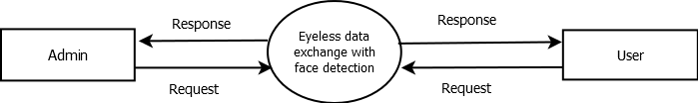

Level 1 DFD
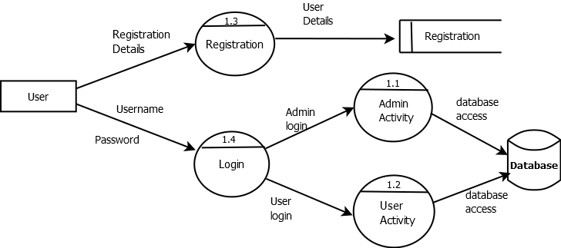

Level 1.1 DFD

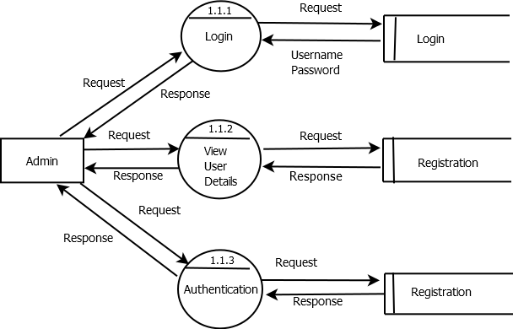

Level 1.2 DFD

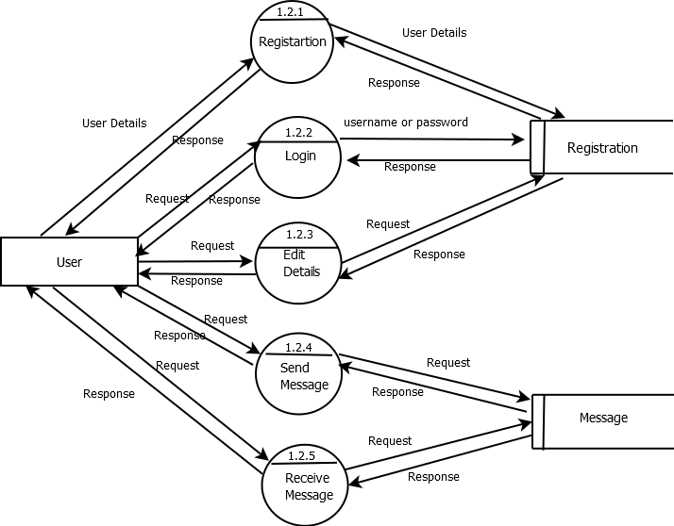

11.2 Table Structure

Table name: admin
Description: To store admin details
Sl.no | Name | Data Type | Constraints | Description
1 | a_id | Int(11) | Primary key | Store admin id
2 | Username | varchar(50) | Not null | Store username
3 | Password | varchar(50) | Not null | Store password

Table name:registration
Description:To store registerd user details

Sl.No | Name | Data Type | Constraints | Description
1 | u_id | Int(11) | Primary key | Store user id
2 | Name | varchar(50) | Not null | Store username
3 | Address | varchar(200) | Not null | Store address
4 | Dob | varchar(20) | Not null | Store dob
5 | Gender | varchar(10) | Not null | Store gender
6 | email_id | varchar(150) | Not null | Store email address
7 | Mobile | varchar(10) | Not null | Store mobile
8 | Image | varchar(100) | Not null | Store image
9 | password | varchar(10) | Not null | Store password
10 | answer | Varchar(100) | Not null | Store answer
11 | Status | varchar(10) | Not null | Store if user is approved or pending

Table name:message
Description:To store message details
Sl.No | Name | Data Type | Constraints | Description
1 | m_id | Int(11) | Primary key | Store message id
2 | from | varchar(250) | Not null | Store from address
3 | sendto | varchar(100) | Not null | Store to whom message is sent
4 | date | varchar(20) | Not null | Store date
5 | subject | varchar(100) | Not null | Store subject
6 | content | varchar(1000) | Not null | Store content
7 | status | varchar(10) | Not null | Store if message is sent or draft

Table name:feedback
Description:To store feedbacks
Sl.No | Name | Data Type | Constraints | Description
1 | f_id | Int(11) | Primary key | Store feedback id
2 | from | varchar(250) | Not null | Store from address
3 | to | varchar(250) | Not null | Store to whom feedback is sent
4 | date | varchar(20) | Not null | Store date
5 | sub | varchar(250) | Not null | Store subject
6 | complaint | varchar(250) | Not null | Store complaint

11.3 Sample Screen Formats

Home Page

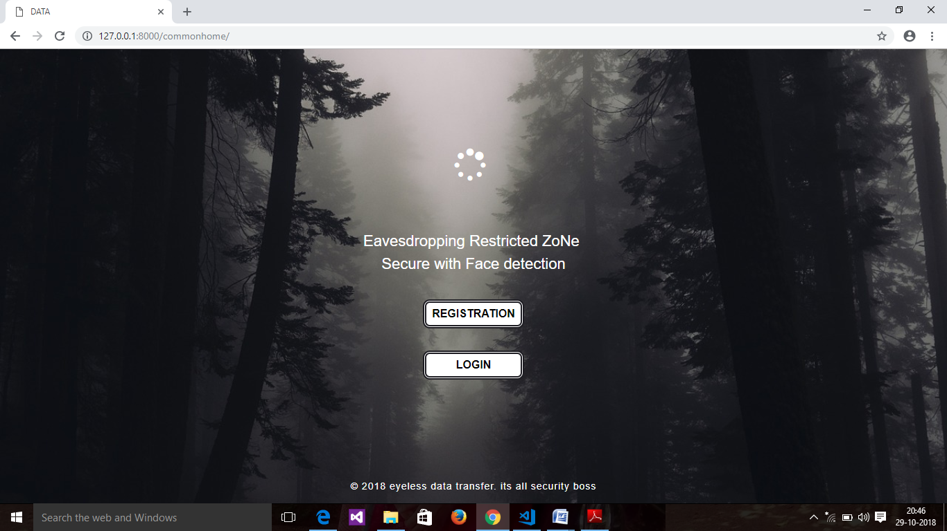

Login page
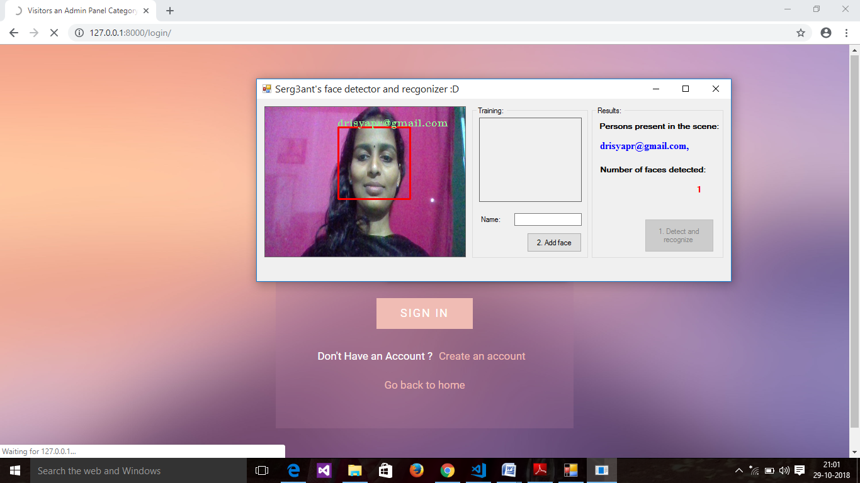

Registration page
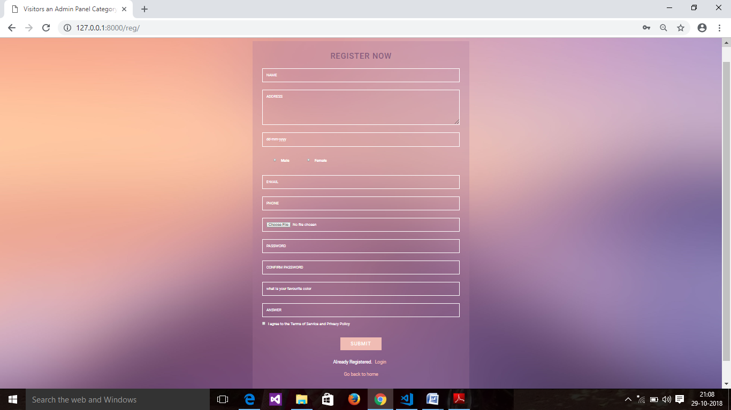

Compose page 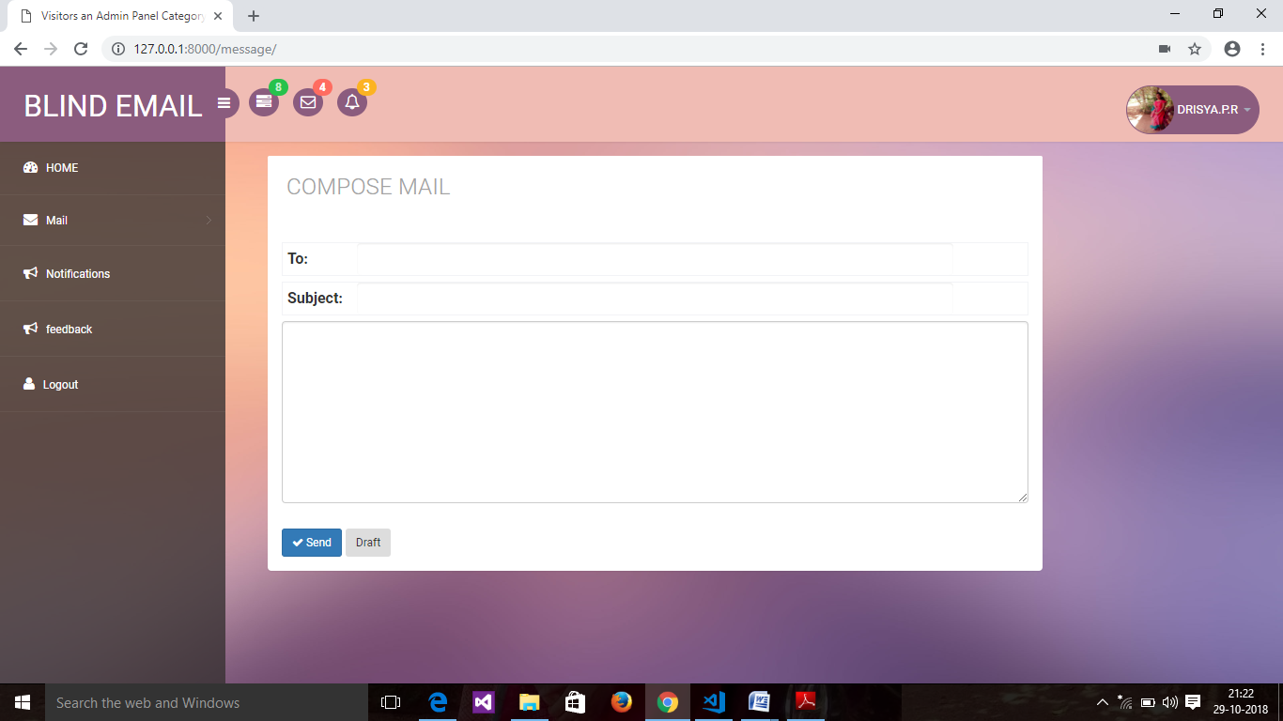

Feedback form
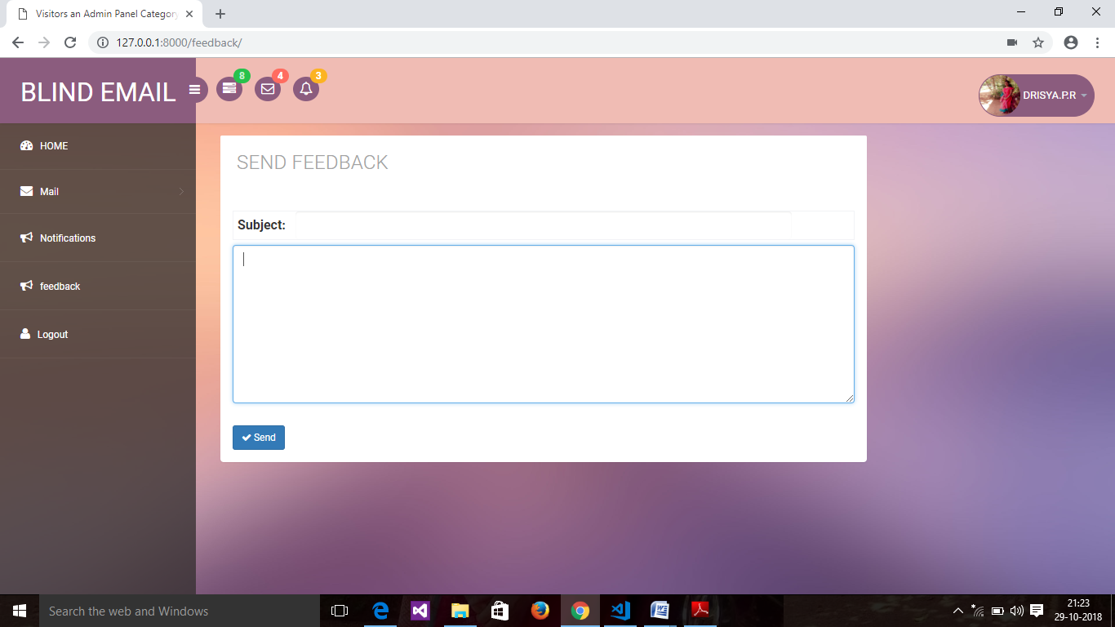

Edit Details
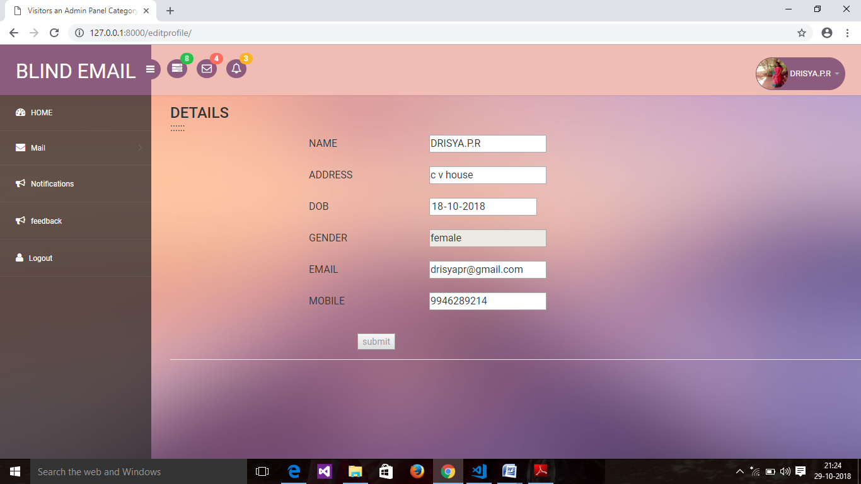

11.4 Reports

